10/15 CS240 – x86 VMM
- Paper Background
  - x86 architecture vendors added virtualization support in 2005 (Intel) / 2006 (AMD)
    - VMware's success showed Intel and AMD that hardware support was worth adding.
    - A VMM could be built on this hardware without the fancy software tricks, but the first generation did not perform well.
    - Both designs copy an old IBM system (it had a paper and patents). Intel would not talk to VMware about its design; when it was ready to launch, it disclosed the design, and VMware immediately identified the problem this paper points out: with no memory virtualization it would not perform well. Adding it took a couple of years.
    - AMD asked VMware what it thought of the same IBM design and then launched something that looked just like Intel's.
    - Intel VT and AMD SVM: the paper treats them as the same design (VMCB, guest mode, vmrun, exit). They add classical virtualization of the CPU only.
    - Memory virtualization support added in 2008 (AMD) / 2009 (Intel)
      - Nested page tables (AMD) and EPT (Intel). The paper (2006) only discusses them as proposals in section 7.4, and expects slightly slower TLB misses but no trace overhead. Only with them could the hardware approach perform better than the software approach.
  - Mechanism: Binary translation vs hardware virtualization
    - Problem (why this paper)
      - VMware must run unmodified x86 operating systems (Windows!) in a VM that is faithful, fast and safe (Popek-Goldberg: fidelity, performance, safety).
      - x86 is not classically virtualizable (trap-and-emulate fails), so VMware built a software VMM using binary translation (BT, 1999).
      - In 2005-06 Intel VT and AMD SVM added hardware that makes classical trap-and-emulate work.
      - The paper compares the hardware VMM against the software VMM.
    - Result of the paper:
      - usually NOT (first-generation hardware). Both run compute-bound user code at about native speed
      - software wins on page-table updates, context switches, I/O and page faults
      - hardware wins only on system-call-heavy workloads in one address space.
    - Mechanisms, in dependency order
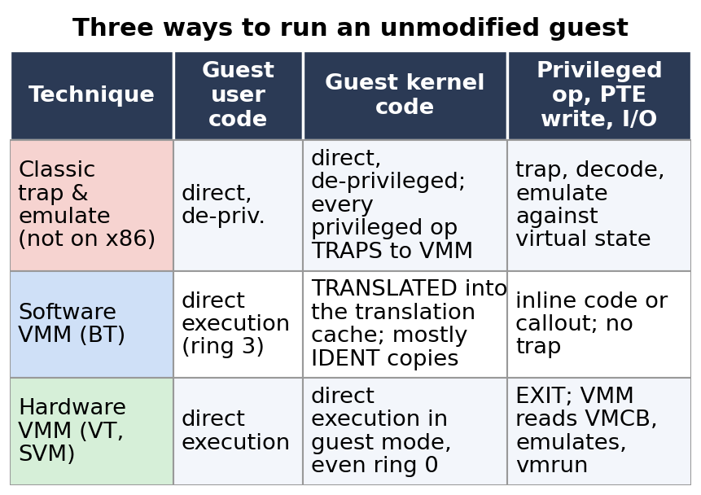
      - Obstacles (virtualizability) → two answers: BT (binary translation, adaptive BT, made safe by protecting the translator) or the hardware VMM.
      - Both need memory virtualization (traces and shadow page tables), which first-generation hardware did not provide; nested page tables are the later hardware fix. Why each VMM wins, and software flexibility vs hardware rigidity, explain the results.
    - Trade-off
      - Software VMM: pays a little on every translated kernel instruction (indirect branches, PC-relative code, system calls), but can replace traps with inline code and adapt.
      - Hardware VMM: guest runs natively until an EXIT, but each exit costs thousands of cycles and the hardware offers a fixed trap-and-emulate model with no room for software tricks.
    - Effect of changes
      - Cheaper exits narrow the hardware gap (Core 2: entry 2409 → 937 cycles) but never close it, because state must be reconstructed. Nested page tables remove traces, hidden faults and the cost of PTE writes and context switches, but make TLB misses cost more. Without segment limits (64-bit Intel) BT's protection fails. A workload with few kernel operations makes the two VMMs tie.
- Virtualizability (Popek and Goldberg)
  - Popek and Goldberg, "Formal requirements for virtualizable third generation architectures", CACM 17, 7 (1974), 412–421
    - Virtualization means making the virtual machine look just like the hardware, so any software that ran on the real hardware should run in the virtual machine.
    - Three criteria for a VMM: Fidelity (software runs identically, barring timing effects), Performance (an overwhelming majority of guest instructions run directly on hardware), Safety (the VMM manages all hardware resources).
    - The paper separates two ideas that were conflated: "classically virtualizable" (can be done by trap-and-emulate alone) and "virtualizable by the P-G criteria" (any technique). x86 is not the first but is the second, via binary translation.
    - By 1985 (x86 protected mode introduced), virtualizable wasn't considered a requirement
      - On IBM mainframes the motive was obvious: machines were rare, big and expensive, so carving one up to give each user their own machine was a nice feature. By the time the x86 protected modes were designed the target was personal PCs, so Intel did not see the need. Making it virtualizable would probably have taken little, but they did not do it.
      - In 1974 trap-and-emulate was so prevalent that "virtualizable" was informally equated with it; x86 designers had no reason to make every sensitive instruction trap. Hence the later obstacles.
  - Run environment in less privileged mode
    - The classic IBM picture is the hardware, an OS running on it, then apps (the birthday cake).
    - Virtualization keeps the hardware the same and adds a layer, the virtual machine monitor or hypervisor, that looks like the hardware, so an entire software stack that used to run on the hardware runs on it, and several stacks can be multiplexed.
    - The OS and the applications run at a less privileged level (like user mode versus the OS in a modern system). Whenever the software does something that accesses the hardware, i.e. a privileged instruction, it traps into the VMM (de-privileging: the first ingredient of trap-and-emulate).
      - Paper section 2.1: the guest still runs directly on the CPU (it is not interpreted) at a reduced privilege level; the VMM intercepts the traps and emulates the trapping instruction against the virtual machine state. Only privileged-state accesses trap.
      - On x86 not all of them trap: popf drops system flags silently, and reads such as the %cs privilege bits or sgdt do not trap, which is why x86 is not classically virtualizable.
  - Trap and emulate
    - The VMM keeps, for each virtual machine, a shadow copy of the privileged hardware state. A privileged operation traps into the VMM, which emulates it against that shadow copy. This technique was very well understood and had been used in industry for years.
      - Hardware state is everything that defines the machine's condition: CPU registers (flags, privilege level, page-table pointer), memory structures the hardware reads (page tables, descriptor tables) and device registers.
      - Privileged state is the part only the kernel may read or write because it affects the whole machine: the interrupt flag IF, the %cr3 page-table pointer, the descriptor-table registers, the CPL bits, page tables and memory-mapped device registers. Unprivileged code that touches it should trap.
      - The shadow copy is the VMM's per-VM record of what the guest believes the privileged state is (virtual IF, virtual %cr3, virtual descriptor tables), kept apart from the real hardware values. The VMM needs the real values for itself: real interrupts stay enabled and the real %cr3 points at the shadow page table. Paper section 2.2: the VMM "maintains an image of the guest register".
      - Example: a guest cli traps, the VMM sets virtual IF = 0 in the copy, and it delivers interrupts to the guest only while the virtual IF is 1. Off-CPU state such as page tables needs a derived shadow table plus memory traces.
      - The copy is also the per-VM state the VMM saves and restores when it switches VMs, like a register save area, and it lets the guest "change" privileged state without touching the real hardware.
      - Real interrupts belong to the physical machine, not to a VM: a device or timer interrupt arrives on the real CPU while any VM runs, and the VMM must take it because it owns the devices, emulates them and needs timer ticks to preempt VMs. If a guest's cli cleared the real IF, that guest could keep the CPU forever.
      - The VMM decides which VM an interrupt is for and holds it pending until that VM's virtual IF is 1. This is reasoning from the design; the paper states only that the VMM keeps virtual IF and guest register images.
    - On a trap the VMM decodes the faulting instruction and emulates it against the virtual machine state (for example an out instruction against a virtual device), then resumes the guest. It is easily verified to meet all three criteria, provided every sensitive instruction really traps; on x86 that fails.
      - OUT is the x86 port-I/O instruction: it writes a value (from AL, AX or EAX) to a device I/O port in a separate port address space, for example a disk controller command register. It is privileged, so a de-privileged guest kernel's OUT faults (general protection fault) into the VMM. This is standard x86 behavior; the steps below are the usual design, not spelled out in the paper or lecture.
      - Steps for a guest out port, al (for example sending a READ command to the disk controller):
        - The guest driver runs the out instruction.
        - The CPU faults to the VMM, saving the guest's registers and IP.
        - The VMM decodes the instruction at the saved IP (opcode, port, data register).
        - The VMM looks up which virtual device owns that port for this VM (a software model of the device kept in the VM's state) and applies the write to the model (command register = READ). The real device is not touched directly; the VMM may start real I/O through its own driver.
        - The VMM advances the guest IP past the OUT and resumes the guest.
        - Later a virtual interrupt is delivered when the emulated operation completes, if the virtual IF allows.
      - Why trap: letting the guest write the real port would give it direct control of a shared device, breaking Safety (the VMM manages all hardware resources) and endangering the other VMs. Paper section 2.1 also notes traps can come from protected memory-mapped device ranges.
  - Mechanism: Virtualizability, Popek-Goldberg, trap-and-emulate, why x86 fails
    - TL;DR
      - Problem – run an unmodified OS in a VM that stays faithful, fast and in control.
      - Mechanism – classic trap-and-emulate: run the guest de-privileged, trap every privileged instruction, emulate it against VMM-kept virtual state; use traces for in-memory state.
      - Trade-off – clean and verifiably correct, but only if EVERY sensitive instruction traps.
      - Breaks when – an instruction reveals or changes privileged state without trapping (x86: %cs, popf, SGDT) or the state lives in memory (page tables).
    - Key points
      - Timing differences are explicitly allowed.
      - p
    - Dependence on assumptions
    - Assumptions this mechanism relies on:
      - Guest kernel is de-privileged (runs outside ring 0)
      - All sensitive instructions trap
      - Privileged state is on-CPU (the VMM can keep an image of it)
      - The guest OS is unmodified (full virtualization)
      - The VM must be indistinguishable from real hardware, timing included
    - Consequences of relaxing an assumption
      - If popf also trapped, trap-and-emulate would be correct, but popf is frequent, so the exit rate would be unacceptable (paper, section 4.4). The hardware therefore keeps a shadow EFLAGS instead.
      - If the guest ran only user code, direct execution would be safe because user code has no sensitive instructions; this is why BT is limited to kernel code.
      - If the guest kernel kept ring 0, there would be no visibility problem, but Safety breaks: the guest would control the hardware.
      - If privileged state lives in memory (page tables, descriptor tables) rather than on-CPU, it needs a shadow copy plus traces.
      - A paravirtualized guest (changed to call the VMM) avoids all of these problems, but gives up fidelity and cannot run closed-source Windows, which was the paper's motivation for BT.
      - If timing may differ from real hardware, a faster or slower instruction is not itself a violation, but a guest can depend on timing.
    - Connections
      - BT and the hardware VMM are two answers to the same obstacles
      - shadow page tables are the in-memory shadow structure
      - ESX's pmap and shadow tables are the same idea.
- x86 Was Considered Not Virtualizable
  - Visibility of privileged state
    - The CPL is stored in the low two bits of %cs. A guest kernel that reads %cs sees it has been de-privileged, a Fidelity violation, and nothing traps.
      - CPL is the current privilege level (ring 0 kernel to ring 3 user), stored in the low two bits of %cs, the code segment selector register. Reading %cs is unprivileged and does not trap, so a de-privileged guest kernel sees a CPL other than 0 and learns it is not really in ring 0. Privileged state leaks, and OS code that checks the CPL misbehaves.
    - Writes would trap, but many of the reads didn’t trap
      - Reads can reveal privileged state to user-level code. The designers figured reading does no harm, as long as you know what mode the processor is in or how the MMU is configured.
  - Lack of traps for some privileged instructions
    - popf in kernel mode changes both ALU flags and system flags such as IF; in a de-privileged context it silently drops the system-flag change instead of trapping, so the VMM cannot keep a virtual IF.
      - popf pops the stack top into EFLAGS, which holds ALU flags (ZF, CF) and system flags (IF is the interrupt enable). In kernel mode it changes both; at user level or de-privileged it changes only the ALU flags and silently ignores IF, with no trap, so the VMM cannot emulate it against the virtual IF.
    - Instruction semantics differ between privilege levels
      - Some instructions are executed both in the kernel and at user level and do slightly different things in the two modes. Running kernel code at the less privileged level therefore does not trap: the instruction just does something different, which breaks trap-and-emulate (popf is the example; the guest kernel has to be moved to a different privilege level, so its instructions change meaning).
        - Semantics means what an instruction is defined to do. For popf, ring 0 loads the ALU flags and IF, while a deprivileged popf "simply suppresses attempts to modify IF; no trap happens" (paper section 3.1). Contrast cli, which faults in ring 3 so the VMM can emulate it. Trap-and-emulate needs the trap; with a silent change the VMM never runs, and moving the guest kernel down a level changes the meaning of its own code (a Fidelity violation).
  - Some x86 modes virtualizable (can use direct execution)
    - The x86 has a whole bunch of modes, some only for backward compatibility, e.g. virtual 8086 mode, which lets very old PC environments run on a modern chip.
    - Direct execution = the guest instruction runs on the real CPU with no VMM involvement. It is safe for code that only uses unprivileged semantics.
    - Most OSes run user-mode code in ring 3
      - On a typical PC OS the user-mode environment does nothing that violates virtualizability. So application code can run directly but operating system code cannot: the VMM does the old trap-and-emulate job for user-mode programs and has to do something special each time execution traps into the OS.
      - So guest applications can run directly (paper: BT is not required for safe execution of most user code on most guests); only guest kernel code needs translation.
      - SGDT
      - Not in the paper. It is the classic sign that x86 leaks privileged state: the paper says "most" user code, not all.
      - SGDT reads the privileged register that the OS sets to point at the machine's segment table (the global descriptor table). It runs at user level and returns a value in the kernel's address space, which is not interesting for an OS to read. But the VMM points that register somewhere in the VMM, so a guest running SGDT sees a different value. Nobody did that, so it was not a big deal.
        - SGDT stores the register's value (table address and size) into memory with no trap. A kernel sets the GDT itself and has no reason to read it back, so almost nobody executed SGDT. The VMM's real GDT holds its own entries, such as truncated guest segments that protect the translator, so the guest sees a value it did not load.
      - The different value is a way to tell you are running inside a VM, which VMware did not consider a breakthrough: it already had documented ways to tell.
      - Terms used above:
        - A segment is a region of the address space described by a base, a limit and access/privilege bits. A segment register (%cs, %ds, %ss, %gs) holds a selector that indexes a table of such descriptors.
        - A segment table (descriptor table) is that array. The GDT is the global descriptor table, the system-wide one; the privileged GDTR register points to it (lgdt sets it, sgdt reads it). The "machine segment table" in the lecture is the GDT the machine is using at that moment.
        - Segments are not virtual memory areas. x86 segments are a hardware mechanism (base, limit and privilege applied to every address before paging). VMAs (for example Linux vm_area_struct) are OS bookkeeping for ranges of a process's virtual address space, enforced through page tables. Modern OSes use flat segments (base 0, full limit) and rely on paging, while the paper uses segment limits on purpose to protect the VMM cheaply. This is general OS knowledge, not defined in the lecture or paper.
    - v8086 mode
      - The 8086-emulation mode inside protected mode, where sensitive instructions trap, so direct execution works. The paper's section 3.1 sets the legacy real and v8086 modes aside and still translates 16-bit code (6,680 16-bit units in an XP boot).
  - Commonly used non-virtualizable mode:
    - The problem modes are the ones that run an OS kernel.
    - Kernel mode – ring 0 execution
      - Guest kernel code is exactly where %cs and popf matter, so it is what binary translation (or hardware guest mode) must handle.
    - Several of the legacy modes (real mode, etc.)
      - Real-mode code was written for processors of the original PC era (4 MHz), so even an interpreter loop could run it faster than the original IBM PC; performance did not matter there. Kernel code does need to run fairly fast, otherwise the virtualization overhead is huge.
      - Booting an OS starts in real mode, so a VMM needs a plan for it too: the software VMM translates it, the hardware VMM runs it in guest mode.
    - Trap and emulate to not do this.
      - Bottom line: trap-and-emulate works for user-level code, but kernel execution and the legacy modes need some other way to be executed.
      - Patching the problem instructions so they always trap (scan the OS binary, find them, patch them) has been tried. It is scary: operating systems have dynamically loaded modules, so not all the code is available for static patching, and some OSes check their own binary to see whether anyone has patched it.
- Example of Problematic x86 (Kernel Mode) Ring 0 Code
  - pushf – save current EFLAGS (including interrupt flag IF)
    - Why this idiom was typical: machines had a single processor, so a critical section could be had by literally disabling interrupts, running the critical code, and re-enabling them at the end.
    - pushf is a problem only when the virtual IF differs from the real IF. It pushes the current flags onto the stack. Most flags (such as the result of the last compare) are harmless, but the interrupt flag and other system flags are the ones being virtualized; if the VMM holds different values in the system part of the flag register, the real values show up on the stack. The VMM must interpose so that the right value is pushed.
      - pushf pushes the real flags register (not a virtual device's value). It is unprivileged and never traps. The VMM keeps the guest's IF in its virtual copy while the real IF stays 1 so it keeps receiving interrupts, so the guest can read a value that differs from its virtual IF.
      - In the sequence pushf, cli, popf the virtual IF is normally 1 and the real IF is 1 at the pushf, so the pushed value matches. The failure in that sequence is popf.
      - pushf matters when the virtual IF is 0 but the real IF is 1, for example in a nested critical section (an outer cli, then an inner pushf pushes the real IF = 1 instead of 0, so the inner restore would turn interrupts on inside the outer section) or when kernel code reads the flags to check whether interrupts are disabled. It is a Fidelity violation with no trap. The nested illustration is not from the lecture, which framed it conditionally ("if the VMM had different values").
      - Fix: BT rewrites pushf to push the virtual flags; the hardware VMM (paper section 4) makes flag instructions operate on the shadow %eflags in the VMCB.
    - Idiom: save the interrupt state, disable interrupts, do the critical section, restore the saved state (so it works whether or not interrupts were on).
    - Pushing the current flags on to the stack. (interrupt flag + other system flags
  - cli – clear interrupt flag (disable interrupts)
    - Privileged, so it traps when de-privileged and the VMM sets a virtual IF = 0. Under BT it becomes inline code; under VT the shadow EFLAGS absorbs it.
  - critical section:
      - VT is Intel VT-x, the hardware support for virtualization (AMD's equivalent is SVM). EFLAGS is the x86 flags register: ALU flags such as ZF and CF plus system flags such as IF.
      - How cli is handled in each approach:
        - De-privileged: cli traps and the VMM sets virtual IF = 0.
        - BT: an inline sequence, vcpu.flags.IF := 0 in the paper, a handful of cycles versus 60 for cli on a Pentium 4.
        - VT: guest mode runs cli on the VMCB's hardware-maintained shadow of the guest %eflags, so there is no exit.
      - The shadow EFLAGS is the desired state. The guest's flag change lands only in the guest's copy, the real flags and the VMM are unaffected, and no exit is needed (paper: instructions operating on %eflags operate on the shadow, "removing the need for exits"). The VMM still delivers a virtual interrupt only while the guest's IF in the copy is 1.
      - Contrast plain de-privileging, which gives a trap for cli (correct, costs an exit) and a silent drop for popf (incorrect). VT makes cli, pushf and popf all correct and exit-free.
    - mov ax, [shared_counter]
    - inc ax
    - mov [shared_counter], ax
    - Ordinary loads, stores and ALU instructions: IDENT translation, or direct execution in guest mode. This is why most kernel code is cheap to virtualize.
      - IDENT ("identically" in the paper) means the translator copies the guest instruction unchanged into the translation cache. Most code can be translated IDENT: loads, stores, ALU instructions, cmp and mov (the first three instructions of the paper's isPrime example).
  - popf – restore saved flags (re-enabling interrupts if enabled)
    - One of the worst: it does not trap, yet it has to set or restore the interrupt flag, i.e. operate on virtualized state, so something special is needed. Effect: at a de-privileged level the IF change is silently ignored, so the virtual IF stays 0 and the guest hangs without interrupts.
      - popf is a problem not because it updates only the virtual state (that would be the desired outcome) but because a de-privileged popf updates neither. It applies the ALU flags, suppresses the IF change in the real register and raises no trap, so the VMM's virtual IF stays 0.
      - Trace (virtual IF = 1 and real IF = 1 at the start):
        - pushf pushes IF = 1.
        - cli traps, the VMM sets virtual IF = 0 and the real IF stays 1.
        - The critical section runs while the VMM holds guest interrupts pending.
        - popf pops IF = 1 but nothing happens to the virtual IF, because there is no trap. The guest thinks interrupts are on, the VMM thinks they are off, pending interrupts are never delivered and the guest hangs.
      - When the saved IF was 0 (the nested case) the suppressed popf is right by luck.
      - Fix: popf must reach the VMM. BT rewrites it inline to set vcpu.flags.IF from the popped value and check for pending interrupts; VT updates the shadow EFLAGS in hardware.
  - Walkthrough: pushf / cli / popf (the slide)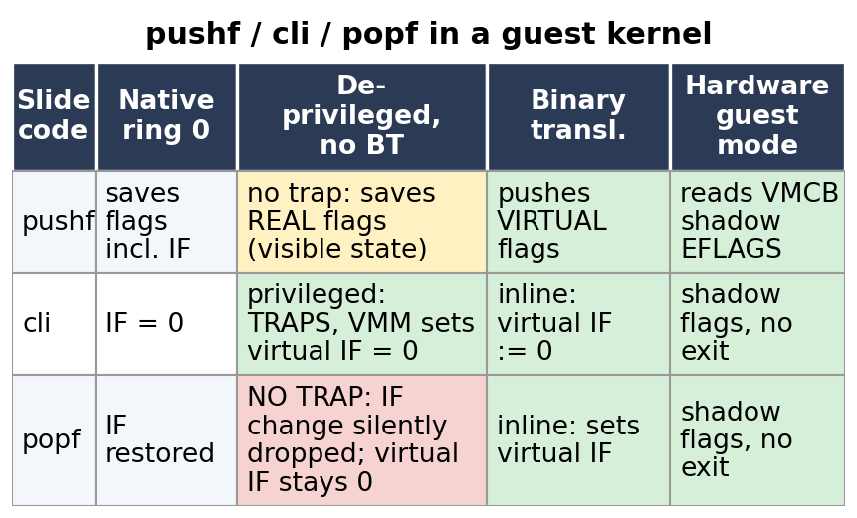
    - De-privileged without BT: cli traps (virtual IF=0), pushf and popf do not trap; popf drops its IF change, so virtual IF stays 0 and the guest never sees interrupts again.
  - ret
    - ret is a problem only because VMware used dynamic binary translation: it pops the return address off the stack and jumps to it, an address unknown when the code was translated. The translator must interpose and look up where the current translation of that address is.
    - The stack is visible to the running software and must hold exactly what it would on the real machine, so translated addresses cannot be stored there.
      - A ret does not trap: it is unprivileged, and the stack holds the original guest return address. The translated ret is an inline sequence in the translation cache:
        - spill %rcx to VMM memory through a %gs override
        - pop the guest return address and find its translation with a hash table lookup
        - jump there, calling the translator if no translation exists yet
        - reload the guest %rcx afterwards.
- Basic Virtualization Approach
  - Create in-memory shadow copy of privileged hardware state
    - Emulation used this in-memory state copy
      - Primary structure = the guest's own view;
      - shadow structure = the VMM-owned copy derived from the guest's primary version, kept for each piece of privileged state the guest believes it controls.
      - On-CPU state (%cr3, flags) is kept as an image in the VMM and used when emulating trapping instructions.
        - Paper section 2.2: the guest's operations on this state trap, and the VMM "maintains an image of the guest register" and updates it while emulating each trapping instruction, starting from the VM's initial reset state (reasoning). Under BT the same updates are inline code. The real register holds something else (real IF stays 1, real %cr3 is the shadow root), so there are two copies here too; the trap is the notification.
    - VMM can use the real hardware state
      - The shadow can be what the hardware really uses (the real IDT points at VMM handlers). Off-CPU state in memory (page tables, descriptor tables) needs traces to stay coherent because stores and even DMA change it with no trapping instruction.
        - Off-CPU state in memory (page tables, memory-mapped devices) can be changed by any ordinary store, and by DMA, with no trap. The primary lives in guest memory, so the VMM can read it whenever it needs to.
        - To keep the shadow in sync the VMM uses memory traces (paper section 2.3): the pages of the primary (for example guest PTEs that have shadow PTEs) are write-protected so a write faults into the VMM, which updates or drops the shadow. Memory-mapped devices are protected for reads and writes. Shadow page tables are filled lazily by reading the guest PTE (a hidden fault).
        - A traced write faults before it happens. The VMM emulates it on the primary (guest memory, the guest's view), propagates it to the shadow (update or drop the shadow PTE) and resumes. The trace fault is a page-protection fault, not an instruction trap, and each traced write costs one.
        - The split is symmetric: there is a copy the guest sees and a copy the hardware uses. For privileged registers the guest sees the VMM's image and the hardware uses the real register. For memory the guest sees its own page table (in guest memory) and the hardware walks the VMM's shadow table, which the real %cr3 points at.
        - Only privileged and system state is split this way; ordinary registers hold the guest's values directly (paper: most virtual registers are bound to their physical counterparts while translated code runs).
    - Each virtual machine has its complete CPU state stored, regular registers included (several VMs can use the same register names), and all the privileged registers are shadowed. Switching virtual machines is like a process context switch: save the current VM's state and load the new one's.
    - All of this state is small except the page tables, which are big hierarchical structures of multiple 4 KB pages.
  - List of x86 privileged hardware state
    - The authors had to be sure they understood all the privileged state of the hardware; this is the complete list.
    - What the VMM must virtualize, from the cheapest (registers kept as an image) to the hardest (page tables in memory).
    - Privileged registers:
      - PT = Page table
      - CR0: the mode the processor is in
      - CR2: the address of the last fault, used by the page fault handler
      - CR3: the page table currently in use
      - CR4: Which features are activated on this hardware. every time a feature was added to the x86 a bit was added here to control whether it is activated, so by this time it had many bits
      - Guest sees virtual values: CR3 is the guest's page-table root (the real %cr3 points at the shadow root), CR2 must be set to the faulting address when the VMM forwards a true page fault, CR0 and CR4 mode and feature bits are what the VMM chooses to expose.
    - Segment descriptor tables (LDT, GDT, IDT) (local, global, interrupt descriptor table)
      - The VMM must also truncate guest segments so it keeps its own view of them.
    - Parts of EFLAGS and %cs
      - The two obstacles of the paper.
    - Page tables
      - The hot spot of the whole paper. It is the only item that needs a fully shadowed copy plus traces.
- VMware's Software VMM – Dynamic Binary Translation
  - Dynamic binary translation history
    - Fast interpreters: Shade → Embra/SimOS
      - Shade (from Sun Labs) instruments a binary, e.g. to count its loads and stores or call your routine, and runs super fast: it reads the program's instructions, instruments them and jumps to the result, so almost all the code it executes was just written out by it. Embra, built by a student of the lecturer, used the same idea in a simulator, which gave the group their dynamic binary translation experience.
    - Just-in-time compilers: Xerox PARC Smalltalk runtime, Self → Java HotSpot
      - Self and other highly dynamic languages write out code that does their dynamic checks, so their implementers knew how to do this.
    - In parallel as VMware: Transmeta CPU
      - Transmeta was a startup building an x86 CPU with binary translation (a VLIW core plus software translation). It hired the author of Shade and nearly everyone else who knew fast binary translation; after Intel killed it, VMware was able to hire those people.
    - VMware's founding idea: rather than trying to patch instructions of an OS running directly, run everything under a dynamic binary translator. Most instructions do not change at all and only the ones that need it are patched. It was kept secret outside the company.
      - The translator handles all guest kernel code (privileged or not), not only privileged instructions; user code runs directly (paper section 3.2). Per instruction it chooses IDENT (copy) or a non-IDENT rewrite (control-flow continuations, inline sequences, callouts).
  - Let's do an inner loop of an x86 dynamic binary translator
    - An x86 CPU executes instructions. The VMM looks at where the program counter (called IP on x86) points and, rather than jumping to that code, lets the translator read the instructions that are about to execute, typically up to the next branch.
    - The loop: read guest bytes at the guest PC, classify them into IR objects, collect a translation unit (at most 12 instructions or until a control-flow instruction), emit a compiled code fragment into the translation cache, run it; its exit continuation calls the translator again. The worked example is isPrime(49) from section 3.2 of the paper.
      - IR means intermediate representation. Paper: the translator reads guest memory at the guest PC, "classifying the bytes as prefixes, opcodes or operands to produce intermediate representation (IR) objects. Each IR object represents one guest instruction."
      - IR objects accumulate into a translation unit (TU): at most 12 instructions or a terminating control-flow instruction. The cap lets all data structures be stack allocated, and a TU is usually a basic block.
    - IDENT, SIMULATOR translations
      - A benign instruction that does not matter for virtualization is just copied: IDENT. If it needs a patch, the translation calls out into the VMM or simulates the operation (SIMULATE).
    - The paper's Figure 1 calls the other translation type SIMULATE (the slide says SIMULATOR): a callout to emulation code, used when adaptation removes a trap.
      - IDENT and SIMULATE are the two translation types in the paper's Figure 1. A trap is not a translation type: it is what happens when IDENT-copied code touches protected state (for example a store to a write-protected guest page table) or a privileged instruction is left to trap. It is the slow path adaptation tries to remove.
      - SIMULATE (callout): the translated code jumps out to emulation code in the VMM runtime, which emulates the instruction; paper rdtsc: 1254 cycles. The callout keeps monitoring, so the instruction can revert to IDENT.
      - Inline (in-TC) emulation: the emulation is written directly into the translated code (cli becomes vcpu.flags.IF := 0), with no call; 216 cycles. Both avoid the trap (2030 cycles); complex operations such as context switches still call out.
      - SIMULATE is one kind of rewrite; others are branch continuations, inline sequences (cli) and the ret lookup. Inherently sensitive instruction types (branches, cli, ret) are non-IDENT from the start. "Innocent until proven guilty" applies to ordinary loads and stores whose danger depends on the data (page-table stores), and the trigger is trapping often, not just being hot.
      - Adaptive translation is not a third choice next to IDENT and SIMULATE but the policy that, over time, moves an instruction that traps often from IDENT to SIMULATE or inline code and back.
    - Chaining
      - Frequently the jmp is omitted on fall through.
      - The translator chooses where each compiled code fragment goes. When the chained target is the CCF placed immediately after, a jump to the next instruction does nothing, so it is dropped and the hot path becomes straight-line code (better icache and branch behavior).
        - The next block is directly following in guest memory, but in the translation cache the translator chooses the placement, so the jmp is dropped only when the chained target is placed right after.
      - After a block runs there is a new program counter, so execution would return to the translator to translate the next block. Two things avoid that:
        - The new program counter is the guest's IP: the guest address of the next instruction to run. While a block runs, the hardware PC is a translation-cache (TC) address, but the guest's execution point has moved to a new guest address (the branch target or the fall-through).
        - The VMM does not watch for a new PC. Each block ends in a continuation stub that carries the guest target address, a constant for direct branches and computed at run time for indirect jmp, call and ret. The stub passes it to the translator, which looks it up in the hash table (guest address to TC address) or translates it; chaining then overwrites the stub with a direct jump to that TC address.
        - A continuation is such a stub: "go to guest address X next". Initially it calls the translator for X (paper: jge becomes two translator-invoking continuations, [takenAddr] and [fallthrAddr]); once X is translated the stub is overwritten with a direct jump.
        - Illustration (invented addresses): a guest block at 0x1000 is translated at TC 0x9000; its fall-through guest target is 0x1010; the stub "go to guest 0x1010" looks up TC 0x9400 (or translates), and after chaining the stub becomes jmp 0x9400.
      - keep track of which blocks are already translated (a hash table lookup) **
      - if a block ends in a jump or call, make it jump straight to the next translation (chaining): the branch first points to a continuation that calls the translator once, and afterwards it is overwritten with a direct jump to the target fragment
      - Quickly all the code that executes has been translated, and execution just jumps between blocks in the translation cache.
    - Adaptive translations
      - A store is very likely benign (it stores into memory), so it gets an IDENT translation. But if the store modifies a page table entry, the VMM must know: the page table is write-protected, so the store page-faults.
      - Adaptive translation: once the VMM sees that a piece of code keeps modifying page tables, instead of trapping each time it generates code that knows it is modifying a page table entry and inlines it in the translation cache at that place (innocent until proven guilty: every instruction starts IDENT; a frequently trapping one is retranslated and a forwarding jump is patched in).
        - The rewritten code is saved in the translation cache, which lives in the VMM's region. The original IDENT fragment gets a forwarding jump to the new SIMULATE or inline fragment (paper Figure 1: ccf1 to ccf5).
        - Rewriting stops the trap because it removes the faulting operation instead of changing the mode: the translated code runs at the same reduced privilege (paper: the output is a "safe subset (mostly user-mode instructions)"). There are two kinds of trap:
          - A privileged instruction run at reduced privilege (cli) faults because of the mode. The rewrite is vcpu.flags.IF := 0, an ordinary store to the VMM's virtual CPU data, since the virtual state lives in VMM memory and the real flag need not change.
          - An ordinary store to a write-protected page (a traced guest page table) faults because of the page protection, in any mode. The rewrite is a VMM-generated sequence that applies the update to the guest's table and to the shadow instead of storing to the protected page; the paper does not spell out the mechanism.
        - Inline does not mean the VMM does not know: the VMM generated the code, so its emulation logic is compiled into the translation cache and no run-time control transfer into the VMM is needed. The translated code is trusted VMM-generated code in the region guest segments are truncated away from, and it reaches VMM data only through the %gs override; the guest cannot reach or change it. In this paper the structures are the guest page table and the shadow page table ("pmap" is ESX's term).
        - Guest PTE store, from the first step:
          - Baseline (trace plus trap): the VMM write-protects the guest page-table page, the guest store faults (a page-protection fault at any privilege), and the VMM decodes it, performs the store on the guest page, updates the shadow PTE and resumes, about 2000 cycles. The guest never updates the shadow table itself.
          - Adaptive BT: the store is replaced by a VMM-written sequence that does both updates itself. Paper (ptemod): "a small program that is cheaper than a trap but still quite costly", 391 cycles per iteration versus a native single-cycle store; hardware VMM 12733 cycles. The program's contents are not given.
          - A trap needs the hardware to see a violating access through the mapping in use, either a privileged instruction at too low a privilege or an access forbidden by the page tables or segments in use. Protection belongs to a mapping, not to the physical page. The paper does not say how the small program writes the protected page; reasoning: through a different, writable mapping controlled by the VMM (the VMM region, reached through the untruncated %gs segment). Clearing and restoring the protection bit is not what the paper describes, and changing protection would itself mean editing the shadow PTE and invalidating the TLB entry.
        - The translation is essentially the trap handler turned into translated code, in one of two forms. Inline variant: the guest's intended operation and the VMM's bookkeeping are both emitted into the translated code. Callout (SIMULATE) variant: the translated code calls a VMM routine that does them. Decoding happens once at translation time (a callout can provide the emulation routine with a predecoded guest instruction, paper section 6).
        - Paper Figure 1: adaptation goes from IDENT (ccf1) to SIMULATE in a new fragment (ccf5) reached by a forwarding jump from ccf1, and "we avoid taking a trap in ccf1 and instead execute a faster callout in ccf5". The paper also says frequent cases may use in-TC emulation that avoids even the callout. For PTE writes it says only "a small program"; which form is not stated.
      - It can switch back and forth. Worst case: the same block-copy routine used everywhere is also used to modify page tables, so it mostly does not trap but sometimes does.
        - A guest OS written to avoid this would use a separate routine for page-table writes. Translation is per instruction location, not per caller, so a shared copy loop gives one store that is harmless for ordinary buffers but traps when aimed at a page table, and adaptation flips between IDENT and SIMULATE, paying for patching and icache loss. A dedicated routine would be adapted once and the general copy would stay IDENT.
        - This design advice is reasoning, not in the paper or lecture. It needs the guest to know it may be virtualized, which goes against VMware's goal of running unmodified guests. General knowledge: kernels usually write PTEs through dedicated helpers anyway.
  - Challenges of x86 code:
    - Both challenges come from translating a system-level binary with no source and no ABI promises.
      - The professor: "if you can imagine a gross thing that somebody does with an instruction set, they kind of did it" (old PC code). Both challenges are from the lecture; the paper does not discuss them (its related points: translation is on demand, which "side-steps the problem of telling code and data apart", and the translator makes no ABI assumptions).
    - Jump into the middle of an instruction sequence
(Not a problem in the new design)
      - Instructions are variable length, so a jump can land in the middle of one and treat that byte as an opcode. Old PC code did this kind of thing. The translator decodes from the actual target when it executes, so the same bytes may get a second translation; on-demand translation sidesteps the code-versus-data problem.
        - x86 instructions are variable length, so the same bytes decode differently depending on where decoding starts. Some old hand-written code jumped into the middle of an instruction on purpose so that a byte in the middle served as an opcode (the lecture does not give the reason). A translator that decoded everything ahead of time, linearly from function starts, would decode it the other way.
        - VMware translates on demand starting at the actual target address and finds translated blocks by guest address in the hash table, so entering mid-instruction misses in the table and a new TU is decoded from there. The same bytes can get two translations, one per entry point; duplicate translation is the cost. Illustration (not from the lecture): the bytes B8 90 90 90 90 are one mov eax, imm32, but entering at the second byte decodes as four nops.
        - The translator did know the x86 instruction set (paper: "Rules are set by the x86 ISA, not by a higher-level ABI"); what it lacked was the source and any guarantee about how the code was built, so translation is binary to binary. The source language is not stated; the lecture's VGA driver example was assembly.
        - The alternative is a translator that decodes ahead of time (the lecture's static patching approach, fragile because of dynamically loaded modules and binaries that check themselves for patching). The cause is the variable-length encoding of x86, not the CPU, which decodes from wherever the PC points. No source says VMware first translated ahead of time; it designed the translator on demand from the start.
    - Dynamically modified instructions
(Can be a problem in the new design)
      - Code that stores into the instructions just ahead of where it is executing exists. Example: the VGA driver everybody used from the original PC graphics card, written in assembly for performance (bit operations moving data around the frame buffer; patching its own upcoming instructions was the fastest way on those processors). Intel's CPU designers had to make this work too, with the instruction already fetched in a deep pipeline.
      - If the guest rewrites code that was already translated, the cached translation is stale . The translator itself also modifies TC code when it chains and adapts.
        - A translation unit is translated before it runs, so a store inside or after it that rewrites upcoming instructions leaves the cached copy holding the old bytes, and the cached translation runs the old instructions (a Fidelity violation). The patched instruction is typically right ahead, in the same block. This remains a real challenge for BT.
        - Lecture fix (not in the paper): memory traces are used for code pages too. The OS's code runs from the translation cache, so if the OS changes its code the VMM invalidates those translations; a write to a traced (write-protected) code page faults and costs one trace fault per write, and the next miss retranslates. Still not stated: how a write inside the currently running fragment is handled.
        - User-mode self-modifying code (a JIT) is avoided, not solved. Paper: "BT is not required for safe execution of most user code on most guest operating systems. By switching guest execution between BT mode and direct execution as the guest switches between kernel- and user-mode, we can limit BT overheads to kernel code and permit application code to run at native speed." User code runs directly, so the CPU's own handling applies and the translation cache is never involved. Which mode the VGA driver ran in is not stated.
  - Mechanism: Binary translation (translator, translation cache, chaining)
    - TL;DR
      - Problem – guest kernel code cannot run directly, and an interpreter is far too slow.
      - Mechanism – translate guest kernel code on demand, one translation unit at a time, into a translation cache
        - copy most instructions unchanged (IDENT), rewire branches through continuations that become chained jumps
        - run user code directly.
      - Trade-off – near-native for ordinary instructions
        - extra cost on PC-relative code, indirect branches (ret) and privileged instructions
        - translation cost is amortized.
      - Breaks when – the translator assumes something the system-level guest need not honor (return addresses, stable code) or the code is mostly cold.
        - Return addresses: the paper contrasts an application-level translator such as Dynamo, which "might assume that return addresses are always produced by calls", with the VMM, which "must run a buffer overflow that clobbers a return address precisely as it would have run natively (producing the same hex numbers in the resulting error message)". So ret needs a run-time lookup and the stack keeps the guest's own address.
        - Stable code: assuming translated code never changes fails with self-modifying code and dynamically loaded modules (the lecture's challenges); nothing promises that code and data are separated.
        - Mostly cold code: translation pays off only if code is reused. Boot and halt of 64-bit XP translates 229,347 64-bit TUs (plus 23,909 32-bit), so translation cost is visible there but still modest at about 2300 cycles per x86 instruction, because the translator does little analysis and the cache captures the working set. "Breaks" is the guide's worst-case framing.
    - Key points
      - Translator properties: binary (input is x86 machine code), dynamic, on demand (lazy: sidesteps telling code from data), system level (no ABI assumptions: a buffer overflow that clobbers a return address must run exactly as native), subsetting (full ISA in, safe mostly-user-mode subset out), adaptive.
      - Output = compiled code fragment (CCF) in the translation cache (TC). A hash table maps guest PC to TC address.
        - The translation cache is the memory region holding the translated fragments; the hash table is its index. It is called a cache because it holds a derived, regenerable copy of guest code and "gradually captures the guest's working set" (paper). Eviction or replacement of its contents is not discussed in the paper or lecture. What does change: stale translations are invalidated when the guest rewrites code, and fragments are rewritten by chaining and adaptation.
      - Non-IDENT cases (PC-relative, direct branches, indirect jmp/call/ret, privileged instructions).
      - BT switches at each kernel/user transition; the translator does not optimize guest code, it only disturbs it minimally.
    - How it works (isPrime(49), section 3.2)
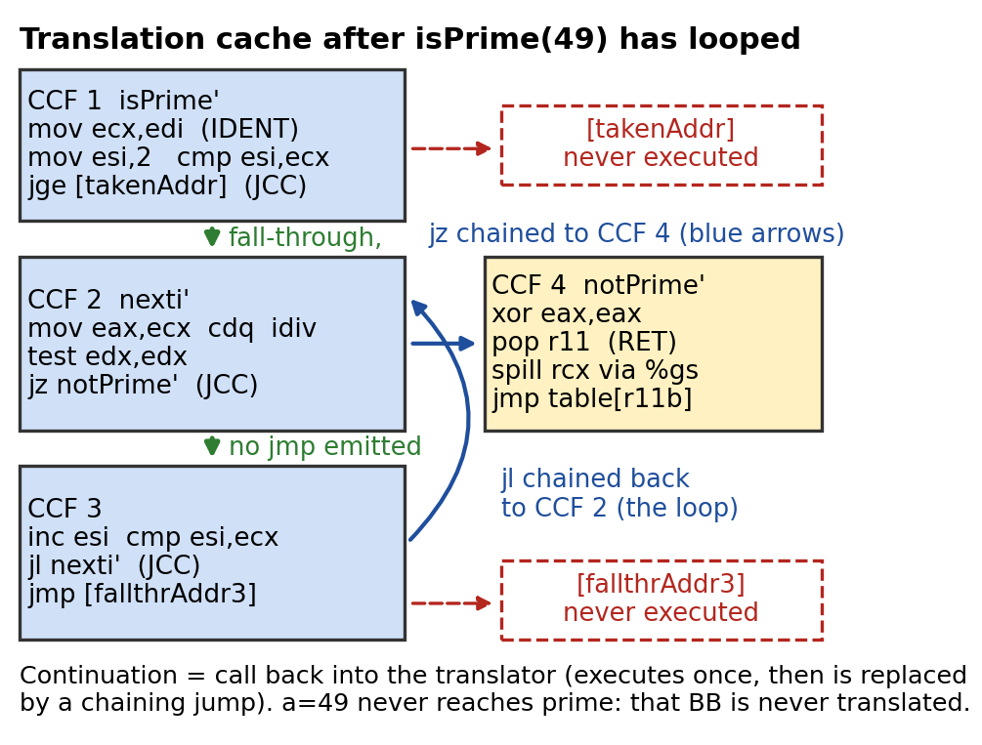
      - 1 jge cannot be copied (layout changes):
        - It becomes JCC + jmp with two continuations.
          - jcc is the family of x86 conditional jumps (je, jne, jz, jg, jge, jl). In the paper's translated listing, "; JCC" (like "; IDENT" and "; RET") is an annotation naming the translation type of that line, not an instruction.
          - Original guest code: jge prime. Translated: jge [takenAddr] followed by jmp [fallthrAddr]. It is still a real jge, but its target is now a continuation, plus an added jmp for the not-taken case. After chaining, the continuations become direct jumps to translated blocks (final listing: jz notPrime' and jl nexti').
          - Taken target: the continuation asks the translator for the translation of the guest address, then chaining overwrites the stub. Not-taken: the fall-through continuation is chained to the next block, and if that block is placed right after in the translation cache the jmp is dropped. In the isPrime(49) example the taken continuation never ran and stays a stub.
      - 2 a=49: jge not taken, so the fall-through continuation translates the next TU (ends in jz).
      - 3 Loop iterates, continuations get chained or elided.
      - 4 Result: 4 CCFs
        - The two never-executed continuations remain
        - The prime-returning block was never translated (execution trace = hot path only).
      - 5 ret becomes pop, spill %rcx through %gs, table jump: an indirect-branch lookup.
      - Full walkthrough of the paper's example (section 3.2):
        - isPrime(a) loops i from 2 to a-1 and returns 0 if a % i == 0, otherwise 1. It compiles to 12 x86 instructions: mov, mov, cmp, jge; then mov, cdq, idiv, test, jz; then inc, cmp, jl; then prime: mov, ret; and notPrime: xor, ret. The translator's input is the hex bytes (89 f9 be 02 ...).
        - TU1 is mov, mov, cmp, jge. The first three are IDENT. The jge is non-IDENT because translation does not preserve code layout, so it becomes two translator-invoking continuations (taken and fall-through).
        - isPrime(49): the jge is not taken, so the fall-through continuation translates TU2 at nexti (it ends with jz, and all but the jz are IDENT). The loop iterates, and chaining replaces continuations with direct jumps and fall-throughs.
        - After the loop there are four CCFs. Two continuations remain because they never executed, two disappeared, and one became a chaining jump to nexti'. The block returning 1 is never translated because 49 is not prime, so the translator captures an execution trace.
        - ret becomes pop %r11, spill %rcx through %gs, movzx %ecx,%r11b, then a jmp through a %gs table indexed by that byte (my reading of the paper's code: a small hash lookup).
      - Instruction by instruction (the paper's listing writes the destination first, so mov %ecx, %edi means ecx = edi):
        - Registers: edi holds the argument a (x86-64 calling convention), ecx a copy of a, esi the loop counter i, and eax and edx the division operands and results (idiv divides edx:eax, with the quotient in eax and the remainder in edx); eax also holds the return value.
        - mov ecx,edi sets ecx = a; mov esi,2 sets i = 2; cmp esi,ecx sets the flags for i versus a and stores no result; jge prime jumps if i >= a.
        - nexti: mov eax,ecx sets eax = a; cdq sign-extends eax into edx:eax, which idiv needs; idiv esi divides edx:eax by i, leaving the quotient in eax and the remainder a % i in edx.
        - test edx,edx sets the zero flag if the remainder is 0; jz notPrime jumps if so; inc esi is i++; cmp esi,ecx and jl nexti loop while i < a.
        - prime: mov eax,1 and ret return 1; notPrime: xor eax,eax sets eax = 0 and ret returns 0.
    - Dependence on assumptions
      - Assumptions this mechanism relies on:
        - Kernel code is already optimized
        - Kernel code is stable (not rewritten at run time)
        - The translator runs lazily, on demand, and caches what it translates
        - Only kernel code needs translating; user code runs directly
        - Translated code is reused often enough to amortize the translation cost
      - Consequences of relaxing an assumption
        - If the VMM interpreted instead of translating, it would stay faithful but fail Performance: interpretation costs hundreds of host instructions per instruction.
          - Same idea as BT: both separate virtual state from physical state and handle guest instructions one by one. Paper: an interpreter "can prevent leakage of privileged state, such as the CPL" and implement popf by the virtual CPL, ensuring Fidelity and Safety.
          - Different cost: an interpreter runs a fetch-decode-execute loop in software on every execution of every instruction ("hundreds of physical instructions per guest instruction"). BT translates a block once into native code kept in the translation cache and runs it directly on the CPU, so decode work is paid once and amortized (a loop is decoded once, not per iteration), and most instructions are copied IDENT and run at native speed. Analogy: interpreter versus JIT compiler.
          - Amortization (translate once per unit, cache, hash table) is the main difference, plus the output being native code the CPU runs directly. A cache of decoded instructions alone would still leave per-instruction emulation work in an interpreter (reasoning). Paper: the translator costs about 2300 cycles per x86 instruction translated and is fast because it "does little analysis".
          - When an interpreter is faithful but BT is not: self-modifying code, because an interpreter fetches and decodes each instruction when it executes and always sees the current bytes, while BT translates ahead and a cached copy can be stale unless the VMM detects the write. A second case from the paper (section 5) is precise exceptions: BT "performs extra work to recover guest state for faults and interrupts in non-IDENT code", which an interpreter has at every instruction boundary. Both are things BT must add machinery for, not unavoidable failures.
        - If user code were translated too, it would be correct but would slow user code (indirect branches, PC-relative addressing) for no benefit.
        - If the guest modifies its own kernel code, the cached translation goes stale; code-page traces cost one trace fault per write. A JIT in user mode never hits this.
        - Mostly cold code, e.g. boot/halt with 229,347 64-bit TUs, makes translation cost matter, but it is still fine at about 2300 cycles per x86 instruction.
        - A guest jump into the middle of an instruction works.
        - Patching the problem instructions in the OS binary ahead of time instead of translating on demand works but is fragile.
    - Connections
      - Adaptive BT patches CCFs
        - The translator's safety relies on protecting the translator (%gs and segment truncation)
        - user/kernel split explains SPECjbb.
  - Mechanism: Adaptive binary translation and inline emulation
    - TL;DR
      - Problem – traps are expensive (about 2000 cycles), and the most frequent trap source is ordinary loads/stores to sensitive data (page tables, devices), not privileged instructions.
      - Mechanism – start every instruction IDENT (innocent until proven guilty)
        - If one traps often, retranslate it as inline code or a callout and patch a forwarding jump
        - revert if it quiets down.
      - Trade-off – trap 2030 → callout 1254 → inline 216 cycles (rdtsc); cost is code patching, icache loss and a forwarding jump, controlled by hysteresis.
      - Breaks when – behavior keeps flipping, or the operation is intrinsically expensive (ptemod: 391 cycles vs native 1).
    - Key points
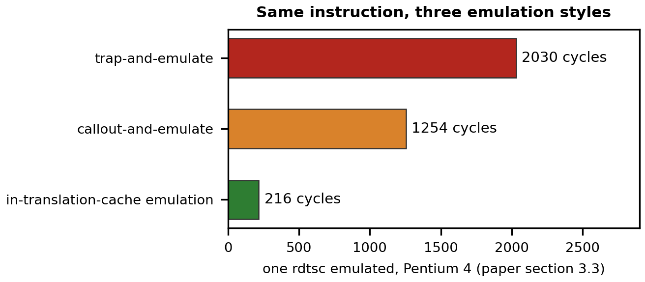
      - A callout beats a trap: no exception entry/exit, and it receives a predecoded instruction (a hardware VMM must fetch and decode the exiting instruction). In-TC emulation avoids even the callout.
      - Adaptation is constant time: a forwarding jump in the first CCF redirects execution to the new SIMULATE translation, so no ancestor CCFs are revisited. Reverting removes the forwarding jump.
        - Ancestors are fragments that chain directly into ccf1. Replacing ccf1's IDENT instruction by a SIMULATE translation (ccf5) naively would require patching every ancestor's jump, work proportional to the number of ancestors. Instead only ccf1 is patched with a forwarding jump to ccf5; ancestors still jump to ccf1 and are redirected, so one patch suffices regardless of ancestors.
        - Reverting removes ccf1's forwarding jump and inserts an opposing one in ccf5 (paper). The cost is one extra jump each time the adapted instruction runs ("dynamic overhead of a forwarding jump").
      - Adapt aggressively toward non-trapping, less aggressively back (hysteresis). It handles more than innocent/guilty: page-table access, a particular device, access to the VMM's address range.
      - The hardware VMM has no equivalent.
    - Dependence on assumptions
      - Assumptions this mechanism relies on:
        - A few instructions cause most of the traps
        - Behavior is stable over time
        - Emulation is no faster than the real hardware operation
      - Consequences of relaxing an assumption
        - Without hysteresis, the adaptive policy causes repeated patching and icache flushes, so static overhead dominates; this is why the policy is asymmetric.
          - Hysteresis means different thresholds for switching each way, so the system does not flip on every small change. Paper: "Adaptation's static overhead, i.e., code patching and resulting loss of icache contents, can be controlled with hysteresis to ensure a low adaptation frequency. We adapt aggressively from a trapping translation to a non-trapping more general form, but less aggressively towards a more optimistic translation."
          - Each switch patches code (a forwarding jump) and loses instruction-cache contents. A policy that reverted as soon as a trap-free stretch appeared would, for an instruction that traps only sometimes, patch back and forth and spend more on patching than it saves.
          - Traps are expensive (about 2000 cycles), so moving to the non-trapping form quickly pays. Moving back is slow, so it only happens when the instruction has been quiet for long.
        - An instruction that was patched and becomes innocent is reverted to IDENT.
        - A hardware VMM with no BT exits on every traced write; only changing what is traced helps (section 5 / algorithm changes).
        - If emulation is faster than the real hardware operation, some guests break: a guest that assumes device latency can fail (e.g. a spin on IN).
    - Connections
      - Traces create the faults that adaptation removes: the binary translator eliminates trap overhead this way.
- Protecting the Translator
  - Steal %gs segment register
    - The translator runs inside the guest OS's address space, so loads and stores keep their addresses and need no address translation: everything that touches memory (most x86 instructions) is just IDENT.
    - Risk: a bad guest pointer that points into where the VMM and translation cache live. It is caught by truncating segments: every segment register except %gs holds a truncated segment that stops below the VMM region, so a translated access into the VMM faults. %gs, a register most operating systems rarely use, stays full range and is reserved for the translator.
      - x86 has six segment registers (CS, SS, DS, ES, FS, GS). Every memory access goes through one (data accesses default to DS, the stack to SS); the register selects a descriptor with a base and a limit, and an instruction can override the register with a prefix such as mov %eax, %gs:0x10. FS and GS have no fixed hardware role; OSes use them for per-thread or per-CPU data and rarely use GS (lecture).
      - The VMM truncates the limits of the other segment registers to exclude the top region, so any access past the limit faults whatever the page tables say, and keeps %gs full range for its own use. "Stealing" %gs means taking for the VMM a register the guest rarely uses. The translator inserts %gs prefixes where it needs VMM memory (the ret spill, vcpu.flags) and strips any %gs prefix a guest instruction has (a non-IDENT translation).
      - Paper listing examples: mov %gs:0xff39eb8(%rip), %rcx (the spill) and jmp %gs:0xfc7dde0(8*%rcx) (the table jump), offsets into VMM data reached through %gs.
      - Bad or malicious guest pointers into the VMM region are caught because ordinary accesses go through truncated segments (paper: "a fault ensues should a translated instruction attempt access to the VMM"). Not stated in the sources: what the VMM does on the fault, and how guest segment-register loads are kept from widening the limits (reasoning: the translator virtualizes them).
      - Why segmentation and not paging is not given beyond "segmentation works best" (reasoning: page-level supervisor/user protection cannot separate a de-privileged guest kernel from the VMM).
      - The VMM was put in the top 4 MB of the guest's address space because most operating systems used it "not at all, or only minor" (lecture); it could not be bigger without hitting things actively in use. On 32-bit x86 that is 0xFFC00000 to 0xFFFFFFFF (segment limit 0xFFBFFFFF). The 4 MB figure is from the lecture; the paper says only "the high part" and its example code is 64-bit, so the numbers do not carry over.
      - General knowledge: on 32-bit x86 the kernel usually occupies the high addresses (Windows commonly above 2 GB, Linux above 3 GB), so the top is kernel space, not application space. What happens when a guest does use that range is not stated (reasoning: its accesses fault and must be emulated, which costs time).
    - Comparing addresses in software is avoided: a load would turn into 2, 3 or more instructions. A single load with the hardware doing the checking is preferred. Of paging and segmentation, the paper chooses segmentation.
    - The translator needs a way to reach VMM data from translated code (it inserts %gs prefixes; the ret translation spills %rcx this way). %gs is left untruncated and used only for that; a guest instruction that has its own %gs prefix is non-IDENT (prefix stripped and emulated).
  - Truncate segments
    - The VMM sits in the high part of the guest address space; every guest segment (except %gs) is truncated so it cannot reach it, giving a hardware fault instead of a per-access check. Not available in Intel 64-bit mode, so the measured software VMM there did not meet Safety.
  - Non-IDENT translations
    - The four cases below are the exceptions where layout or privilege forces different code.
    - PC-relative addressing (call, jmp, jcc)
      - The copy lives at a different address than the original, so PC-relative offsets need compensation code: small code expansion and slowdown.
    - Direct control flow
      - Calls are not a problem: they push the return address and jump, so two instructions instead of one, and run about as fast.
      - Targets are known at translation time, so the translator maps guest address to TC address; negligible slowdown.
        - Direct means the target is fixed in the instruction (jmp, jge or jl to a label, call to a function). The translator maps the guest address to a translation-cache address once (continuation, then chaining); paper: "The net slowdown is insignificant."
    - Indirect control flow (ret, jmp via register or memory)
      - Not known at translation time
      - Returns are a much bigger problem, and so are indirect jumps through a register (rarer, e.g. some switch statements): the register holds the guest target, so the code must find the translation for it (a hash-table lookup) and jump there, which has bigger overhead.
        - typical overhead is a single-digit percentage
        - The call/ret nanobenchmark shows 51 cycles per call/ret pair on the software VMM versus 11 on native and on the hardware VMM, a 40-cycle penalty.
        - Indirect means the target is computed at run time from a register or memory (jmp or call through a register, jump tables, ret, whose target comes off the stack). Paper: it "does not go to a fixed target, preventing translation-time binding. Instead, the translated target must be computed dynamically, e.g., with a hash table lookup".
        - Both need translation: direct pays once, indirect pays on every execution. A conditional jump does not return anywhere; a call pushes the guest's own return address, and ret is indirect.
    - Privileged instructions
      - Simple ones are emulated inline in the TC (cli: a few cycles vs 60 natively), complex ones such as context switches call out to the runtime (measurable callout plus emulation cost).
  - Mechanism: Protecting the translator (%gs and segment truncation)
    - TL;DR
      - Problem – translated code runs in the same address space as the VMM; guest instructions must not touch VMM memory (Safety), without checking every access in software.
      - Mechanism – VMM sits in the high part of the guest address space
        - guest segments are truncated below it, so a stray access faults
        - %gs is stolen: left untruncated, used for VMM data.
      - Trade-off – free hardware checks on every access, but the guest loses the top of its address space and everything depends on segment limits.
      - Breaks when – no segment limits: Intel 64-bit mode (the measured software VMM then fails Safety; Opteron has limits).
    - Dependence on assumptions
      - Assumptions this mechanism relies on:
        - The VMM sits in the high part of the guest address space and translated code shares it, and every guest segment except %gs is truncated, so a stray access faults
        - Segment limits exist (not Intel 64-bit mode)
        - Hardware checks are free on every access
      - Consequences of relaxing an assumption
        - Per-access software checks are safe on any hardware, but a load would turn into 2-3 or more instructions, slowing every load and store; the paper rejects it.
        - Running in 64-bit mode without segment limits breaks Safety: another protection scheme is needed (paper, section 7.3, for BT on Intel), and until then BT is unsafe there.
          - It is the software (BT) VMM that fails Safety, and only on the measured Intel chip; performance is similar on AMD Opteron, where 64-bit segment limits exist, so the measurements are representative (paper section 6). The paper does not spell out the consequence. Reasoning: both reading and writing the VMM's memory become possible, and writing is the severe one (corrupting translated code, shadow tables or virtual state, or running code at VMM privilege and breaking isolation), while reading leaks VMM data.
        - With a hardware VMM this mechanism is not needed: guest mode isolates the guest.
        - A VMM in its own address space would switch page tables on every trap, which is much more expensive.
    - Connections
      - Every IDENT translation assumes it; hybrid VMM on Intel needs a replacement.
- Memory Tracing
  - memory_trace(address, handler_to_call)
    - The VMM must get control when the guest touches particular memory addresses, and what to do depends on the address. So there is an interface to put a trace on an address and name the routine to call as soon as the access happens. In short, a trace is a VMM-registered callback on a guest memory region.
      - Invalidate translation caches
      - MMIO
    - Types: page tables, GDT, LDT, IDT, code pages
      - page tables
      - segment tables
      - code pages: the OS's code runs from the translation cache, so if the OS changes its own code the VMM must invalidate those translations
        - Lecture (memory-trace discussion): "We even used it for code pages". The OS's code is translated into the translation cache and run from there, so if the OS changes its code the VMM must invalidate those translations. The paper has no equivalent text.
      - memory-mapped I/O devices (programmed I/O, reads and writes protected): traces attach to the device and emulate it; in and out instructions can instead be handled by translator callouts
        - Read protection (an x86 mechanism, not spelled out in the paper): the shadow page-table entry for that page is marked not present (a read-only entry traps only writes), so any load or store page-faults into the VMM.
        - MMIO accesses are ordinary loads and stores to device-register addresses (programmed I/O), so the VMM learns of each access through this synchronous trace fault, not through hardware interrupts. It decodes the instruction and calls the handler registered for that address (memory_trace(address, handler)). The handler updates or reads the virtual device's state (a software model) and supplies the loaded value for reads, then the VMM advances the guest IP and resumes.
        - Physical interrupts matter separately: if emulation starts real I/O, the real device's interrupt arrives at the VMM, which updates the virtual device state and injects a virtual interrupt into the guest when the virtual IF allows. in and out port instructions need no page protection, because the translator turns them into callouts.
  - Implementation
    - Traces use the page permission bits. As soon as the guest starts using a page as a page table, a trace goes on it so any write traps into the VMM. When the guest changes a page table entry (a store into that page), the VMM sees the change (a fault, decoded and emulated against the guest structure, as for a privileged-instruction trap) and updates the shadow page table it is actually running on.
  - Overheads
    - Each trace fault is a full trap (thousands of cycles) for a store that natively costs one cycle (ptemod: 1 native vs 391 software vs 12733 hardware). The guest also loses writes at full speed on every traced page.
    - Eliminating trap overhead with the binary translator
      - For traces, the translation updates the shadow page table inline in the translation cache instead of trapping.
  - Adaptive BT: How it works (guest PTE write)
    - Guest PTE write inside a traced page: first executions trap (trace fault). The translator notices, retranslates that store into a small emulation routine that updates both the guest PTE and the shadow, and patches a forwarding jump. Each later execution costs 391 cycles, not a trap. The hardware VMM cannot do this: every traced write is an exit (12733 cycles).
  - Mechanism: Memory traces and shadow page tables
    - TL;DR
      - Problem – the hardware walks the guest's page tables, but the VMM must map guest virtual addresses to machine addresses and see every PTE change; stores to PTEs do not trap.
      - Mechanism – the VMM builds shadow page tables (gVA → machine address) as a cache of the guest's, points the real %cr3 at them, and keeps them coherent with traces (page protection on guest page-table pages).
      - Trade-off – three-way: trace costs vs hidden page faults vs context-switch cost.
      - Breaks when – the workload writes PTEs, switches address spaces or faults heavily (fork-style), and each costs an exit or trap.
    - Key points
      - Trace fault = decode, emulate on the primary structure, propagate to the shadow. Hidden page faults.
      - Workstation 2.0 dropped traces aggressively; modern BT adapts to trace accesses cheaply, so it uses traces liberally (the trade-off is under Memory Virtualization – Shadow Page Tables).
        - This is about two software tracing strategies, not nested paging (paper section 7.2). x86's relaxed TLB coherency rules permit strategies other than tracing. Workstation 2.0 (2000) "would aggressively drop traces upon guest page table modification, allowing the shadow page tables to become temporarily incoherent with the guest page tables", which cut trace costs.
        - The drawbacks: work shifted into the guest page-table reload path, which must process the backlog of PTE writes, and a blocked optimization. A not-present to present PTE write is almost always followed by a user access, so a trace lets the VMM install the shadow entry eagerly and save a hidden page fault (important for forkwait).
        - Since then the binary translator "has become increasingly capable of adapting to trace accesses, allowing our software MMU to make liberal use of traces". That extreme is not optimal for the hardware VMM, where trace accesses cost more (exits). Nested paging (24 references on a miss) is the separate hardware approach of section 7.4, which removes traces altogether.
      - Tracing enables an optimization: on a not-present → present PTE write (demand paging) the VMM installs the present shadow PTE at once, saving the hidden fault that would follow immediately. Important for fork-like workloads.
    - Dependence on assumptions
      - Assumptions this mechanism relies on:
        - x86 has relaxed TLB coherence (the guest must flush or load cr3 before relying on a PTE change)
        - Traces are cheap enough
        - Mappings are 4KB
        - The MMU is virtualized in software, with shadow page tables
      - Consequences of relaxing an assumption
        - Dropping all traces makes PTE writes free, but the shadow stays stale until a flush or cr3 load, so the cost reappears as hidden faults and context switches. It is still correct.
        - If traces cost an exit, as on the hardware VMM (12733 vs 391 cycles), the liberal-trace point is no longer optimal; VMware explored less trace-intensive algorithms.
        - With one address space and few PTE changes (e.g. Apache on Windows), traces rarely fire, so the hardware VMM does fine.
        - Nested paging replaces shadow tables: the shadow tables, traces and the exits they cause disappear, at the price of costlier TLB misses.
    - Connections
      - ESX shadow page tables are this mechanism
        - adaptive BT removes the trace-fault trap
        - hardware VMM inherits it unchanged.
- Hardware Virtualization: Intel VT and AMD SVM
  - Virtual Machine Control Block
    - This is the old IBM idea: run the VM until it traps into the hypervisor. The CPU runs in a mode where it executes the virtual machine directly, and when it traps the hardware itself writes the state back into a memory location.
      - This is IBM System/370 interpretive execution (SIE): the VMM encodes guest state in a hardware format and executes SIE, and many operations that would trap access shadow fields. It came decades before the paper; Intel and AMD copied it from IBM's paper and patents (lecture), and the paper says x86 vendors introduce "hardware facilities inspired by interpretive execution". It is also what hypervisors use today (lecture: cloud VMs all do this), now with nested page tables added.
    - A per-guest in-memory structure: control bits (which events exit) plus a subset of guest CPU state, with diagnostic fields describing why an exit occurred (for I/O: port, width, direction).
      - The VMCB is the interface between the VMM and the hardware. Control bits flow from the VMM to the hardware (which events exit), guest CPU state is loaded on vmrun and saved on exit, and diagnostic fields flow from the hardware to the VMM (the exit reason).
      - An exit is the hardware transferring from guest mode back to the VMM (host mode); vmrun is the opposite direction. Paper section 4.1: guest mode is "a new, less privileged execution mode" that runs guest code directly, including privileged code. vmrun loads guest state from the VMCB and enters guest mode, and guest execution proceeds "until some condition, expressed by the VMM using control bits of the VMCB, is reached". The hardware then "saves guest state to the VMCB, loads VMM-supplied state into the hardware, and resumes in host mode, now executing the VMM".
      - The VMM reads the exit reason from the diagnostic fields (for I/O: port, width, direction), emulates the effect in the VMCB and executes vmrun again. After an exit it either emulates quickly and vmruns the same guest, or starts real I/O and later injects a virtual interrupt.
      - Each guest has its own VMCB, so switching guests is a vmrun on another guest's VMCB. Paper section 4.2 describes the single-guest loop (fill in the VMCB, vmrun, read the exit fields, vector to emulation code); choosing another guest while one waits on slow I/O is the VMM's scheduling, which the paper does not discuss.
      - For pure virtualization the hardware VMM programs exits on guest page faults, TLB flushes and address-space switches (to maintain shadow page tables), on I/O instructions (emulated device models) and on accesses to privileged data structures (page tables, memory-mapped devices). A hypervisor for a trusted general-purpose OS could instead let the guest drive peripherals, handle interrupts or build page tables.
    - Held all the privileged state
    - Shadow privilege state
      - The VMCB also holds a hardware-maintained shadow of %eflags, so popf and cli run in guest mode without exits.
        - The shadow %eflags is virtual CPU state, not device state: the VMCB holds a subset of the guest virtual CPU's state, and in guest mode flag instructions operate on that copy. Under BT the same role is played by the software field vcpu.flags kept by the translator. Virtual devices (for example the emulated disk controller for out) are separate software models.
    - Access in special VMM mode with special instructions
      - The VMCB is an in-memory structure that only host mode touches (vmread, vmrun and friends; the paper counts about ten vmreads per typical exit). The guest cannot see or change it.
  - vmrun the Virtual Machine Control Block until it needs to exit back to the VMM
    - A single instruction points at the block and loads it, and the CPU then runs the virtual machine. On a trap it exits that mode and the state sits in the hypervisor's memory. An exit saves guest state and loads VMM state; the VMM emulates, then vmruns again. Each transition costs about 1000-2500 cycles.
    - Can directly execute the guest OS and applications
      - Most things do not trap: pushf and popf do the right thing in this mode, there is no binary translator so calls and returns are unchanged, and the guest runs at full speed. The traps that remain are even more expensive, since all the state is saved into the control block.
      - In guest mode even guest ring-0 code runs directly; system calls and traps use the guest's own IDT with no VMM involvement, and ALU, branch and flag instructions (hardware-maintained shadow EFLAGS) need no exit either. Exits happen only on conditions the VMM selects in the VMCB (pure virtualization, guest on a short leash): guest page faults, %cr3 loads, TLB flushes, I/O instructions, accesses to traced pages and memory-mapped devices.
        - Guest page faults: the hardware walks the VMM's shadow page table, not the guest's own, so every page fault must reach the VMM first. The VMM tells a true fault (the guest's own entry forbids the access; forwarded to the guest) from a hidden fault (the shadow entry is just missing; it builds the shadow entry and resumes, and the guest never sees it).
        - %cr3 loads: a guest %cr3 load is an address-space switch (a context switch to another process). The hardware must not use the guest's page-table root, so the VMM intercepts, builds or finds the shadow page table for the new address space, and points the VMCB's page-table register at it (the paper's fork example).
        - TLB flushes: a flush (an INVLPG or a %cr3 reload) tells the hardware that a mapping was removed or made more restrictive. The shadow table is a derived copy, so the VMM must drop the matching shadow entries; otherwise a stale shadow entry would keep a removed mapping alive.
        - I/O instructions: the guest must not drive the real, shared device. The exit gives the port, width and direction, and the VMM runs the emulated model of that device (device models are shared with the software VMM).
        - Accesses to traced pages: to learn of changes to the guest's page tables, the VMM write-protects the guest page-table pages (traces). A guest page-table write faults and exits, and the VMM decodes the store, applies it to the guest's table and propagates it to the shadow. This is the costly case: the paper measures about 12,733 cycles per PTE write on the hardware VMM.
        - Memory-mapped devices: the device registers are ordinary addresses, so the VMM protects those pages for both reads and writes. Each load or store faults and exits, and the VMM emulates the device and supplies or accepts the value.
    - Need VMM to do device emulation and memory virtualization
      - In VMware's software VMM, most traps were caused by changes to page tables, and this hardware does nothing about them: without memory virtualization the VMM still shadows the page tables and updates the shadow. So it would not work great for workloads with lots of traps. The hardware virtualizes only the CPU: I/O instructions exit to software device models (device emulation, interrupt delivery and logging are shared with the software VMM), and shadow page tables with traces remain. That is the root cause of the paper's finding.
  - Mechanism: The hardware VMM (VMCB, vmrun, exits)
    - TL;DR
      - Problem – make classical trap-and-emulate possible on x86 without BT.
      - Mechanism – a VMCB in memory holds control bits plus a subset of guest CPU state
        - vmrun enters guest mode (guest runs directly, even ring 0) until a condition chosen by the VMM triggers an exit
        - The VMM reads the VMCB, emulates, vmruns again.
      - Trade-off – native speed until an exit; exits are expensive and the model is rigid: exits are all-or-nothing per VMCB condition and nothing can be rewritten (no adaptation).
      - Breaks when – exits are frequent: PTE writes, context switches, hidden faults, I/O. The MMU and I/O are NOT virtualized.
    - Key points
      - Guest mode (new, less privileged, runs the guest including privileged code) vs host mode (the old x86 environment).
      - Exit costs (cycles, P4 / Core 2): VM entry 2409 / 937, page-fault exit 1931 / 1186, VMCB read 178 / 52, write 171 / 44. The VMM is "stateless" and rebuilds guest state at each exit (about ten vmreads; sometimes instruction decoding).
      - Performance is set by exit frequency: no exits = native; every instruction exits = dominated by transitions.
    - Dependence on assumptions
      - Assumptions this mechanism relies on:
        - Exits are rare
        - Exits are cheap
        - The MMU is virtualized in software
        - The guest is not trusted with page tables or interrupts
      - Consequences of relaxing an assumption
        - Cheaper exits (Core 2) narrow the gap: forkwait slowdown goes from 17.7x to 14.8x. Exits still reconstruct state, so the software VMM stays ahead (from 6.1x to 7.0x).
        - A guest that never exits runs at native speed, but a guest that does no I/O is useless.
          - Paper section 4.3: "The exit rate is a function of guest behavior, hardware design, and VMM software design: a guest that only computes never needs to exit." The "useless" wording is the guide's, not the paper's or lecture's.
          - All device access (in/out, memory-mapped registers) exits so the VMM can run the emulated device, so a guest with zero exits has no way to take input or show output. A real guest also exits for timer interrupts and page-table work, so a never-exit guest is a limiting case, not a real workload. The paper's compute-bound SPECint results run near native on both VMMs.
        - Trusting the guest with more (page tables, interrupts) means fewer exits but weaker isolation; pure virtualization keeps the guest on a short leash.
    - Connections
      - Inherits shadow page tables and traces
        - compared with BT in Why each VMM wins
        - nested paging is the hardware answer.
  - Mechanism: Software flexibility vs hardware rigidity (timing, 4KB mappings)
    - TL;DR
      - Problem – a guest may depend on something the VMM changes (timing), and a feature baked into hardware cannot be adjusted.
      - Mechanism – BT lets the VMM redefine what any instruction does per guest, shippable as a software update; the hardware exposes one fixed trap-and-emulate model.
      - Trade-off – software flexibility costs engineering; hardware is simpler but frozen at design time.
      - Breaks when – the fix needs changed silicon.
    - Key points
      - Popek-Goldberg tolerate timing differences, but real guests can depend on them. BT-emulated IN took 216 cycles vs 3209 native, so the spin loop could exit before the device was ready.
      - Who can change what, and when: the behavior of a BT-emulated instruction lives in vendor-controlled software, replaceable per guest in the next release. The latency of a CPU instruction is fixed in shipped silicon for every program on every machine, and the vendor cannot know which software depends on it.
      - Paper's conclusion: hardware should support the proven software techniques (adaptation, trace flexibility) instead of replacing them; CISC-like all-in-one packaging is hard to exploit without giving up existing software.
      - 4KB shadow mappings, across the two VMware papers: the granularity of a trace (write-protect one page-table, descriptor-table, code or device page) and of ESX's per-page tricks (content-based sharing and copy-on-write, ballooning, paging one page) is the size of the mapping. Cost: more TLB entries and misses than superpage mappings.
    - Dependence on assumptions
      - Assumptions this mechanism relies on:
        - BT lets the VMM redefine what any instruction does, per guest, shipped as a software update
        - Hardware exposes one fixed trap-and-emulate model, frozen at design time
        - Shadow mappings are 4KB, so traces and per-page tricks have 4KB granularity
      - Consequences of relaxing an assumption
        - If a guest relies on timing and the VMM is hardware-only, the problem cannot be adjusted in the field: compatibility fixes become CPU or microcode changes.
        - Superpages in the shadow tables would give guest superpage mappings (the kernel) better TLB reach, but traces and sharing become coarser (a trace on one 4KB guest page would cover a 2-4MB region), and scattered 4KB machine pages are not allowed.
        - If the hardware let software choose which events exit, it would give finer control, closer to what the paper asks for.
    - Connections
      - Adaptive BT is what makes the IN fix possible; ESX (page sharing, ballooning) and Superpages (TLB reach) supply the 4KB trade-off.
- Memory Virtualization – Shadow Page Tables
  - Recall from ESX lecture
    - Mental model: the guest builds a page table in its own memory, but the hardware is never pointed at it. It points at a shadow page table in the VMM. The shadow write-protects pages that need a trace, even if they are writable in the guest OS. Shadow page tables were well known at the time.
    - Same structure as ESX's shadow page tables: the guest maps virtual to guest-physical and the VMM keeps a shadow mapping virtual to machine. This paper adds the true/hidden fault distinction and the cost accounting.
      - Which structure is per VM and which per process (shadow-paging VMM):
        - PPN to MPN (guest-physical to machine memory): one per VM, shared by all of the VM's processes (ESX's pmap).
        - Guest page table (VPN to PPN): one per guest address space (process).
        - Shadow page table (VPN to MPN): one per guest address space too, derived from the guest table plus the VM's PPN to MPN mapping and filled lazily by hidden faults. More exactly it is per guest page-table root (per distinct %cr3 value), so threads of one process share one. Reasoning: one physical address space per guest and one virtual address space per process, so the shadow, a VPN map, is per process.
        - Paper section 2.4: the VMM "manages its shadow page tables as a cache of the guest page tables"; in the fork example, on the child's %cr3 load "the VMM's software MMU constructs a new shadow page table and points the VMCB's page-table register at it". This paper does not name a pmap for the shadow design; the guest-physical to host-physical translation appears explicitly only in the nested-paging section. "pmap" is ESX's term.
  - Consider the tradeoff:
    - Trace costs
      - Trace costs: every page used as a guest page table is write-protected.
      - Many traces keep the shadow coherent but every guest PTE write faults; the paper's fork example shows a PTE write exits on the hardware VMM.
    - Hidden page faults
      - A hidden page fault is not a page fault for the guest OS: it comes from the VMM because of the shadow page table.
      - Filling the shadow lazily:
        - Mirroring the whole guest page table into a full shadow every time the guest sets %cr3 would make setting a page table an incredibly expensive operation.
        - Instead, setting %cr3 starts a totally blank shadow page table, so the first translation faults because nothing is valid. (Process switch within a VM)
          - A guest %cr3 load is the guest OS switching to another of its own address spaces (a process switch; also exec and similar). It exits in the hardware VMM and is handled by the VMM.
          - Switching between VMs is the VMM's own world switch (like a process context switch: save the current VM's state, load the new one's). It loads that VM's state including its shadow root and is not a guest %cr3 instruction; each VM has its own shadow tables.
          - The blank-shadow rule applies to the guest's %cr3 set. Paper: avoiding traces costs "either a large number of hidden faults or an expensive context switch to prevalidate shadow page tables for the new context". Whether shadow tables are cached across switches is not stated.
        - That fault may not be a guest fault (the real page table may hold a mapping). The VMM allocates the shadow page, fills in a valid entry and resumes; the guest never sees a fault.
      - So the shadow page table is effectively a cache of page table pages, filled on reference rather than eagerly.
      - Fewer traces mean the shadow lags the guest (legal because x86 TLB coherence is relaxed: the guest flushes after changing PTEs), so first touches miss in the shadow and the VMM must fill them. True faults (guest PTE forbids) are forwarded to the guest. The VMM must take every fault to tell which.
    - Context switch cost
      - The question is how important fast context switching is versus the cost of hidden page faults. The paper cut trace costs using the binary translator and stayed lazy, building a shadow page table page only on first access, which worked reasonably well with how the OSes of the time used their page tables.
      - Without traces the VMM must reconcile or prevalidate the shadow for the new address space when the guest loads %cr3. The paper calls this three-way balance surprisingly hard and critical to performance.
        - The shadow must stay coherent with the guest page tables, and the paper's three-way trade-off is:
          - Trace costs: write-protect the guest page tables, which keeps the shadow coherent but costs a fault on every guest PTE write.
          - Hidden page faults: fill the shadow lazily, so the first touch of a page faults into the VMM.
          - Context-switch cost: on a guest %cr3 load either build or prevalidate the new address space's shadow up front (an expensive switch with few hidden faults) or start blank (a cheap switch with many hidden faults).
        - Paper: "striking a favorable balance ... is surprising both in its difficulty and its criticality to VMM performance", and "Tools that make this trade-off more forgiving are rare and precious". The hardware VMM replaces faults with costlier round-trips, which makes all three corners worse, and it cannot adapt. Nested paging (section 7.4) removes the whole trade-off.
        - "Cutting trace costs" means making trace faults cheap, not removing traces. Adaptive BT replaces the frequently trapping page-table stores (ordinary store instructions in guest kernel code that hit traced pages) with callouts or in-cache code, so no hardware trap happens. Paper section 7.2: the translator "has become increasingly capable of adapting to trace accesses, allowing our software MMU to make liberal use of traces", whereas Workstation 2.0 dropped traces.
        - Why the three costs must be optimized together: there is one underlying job, keeping the shadow equal to the guest page tables.
          - Traces do it by faulting on every guest PTE write. After that the shadow can be trusted, and a %cr3 load needs no prevalidation.
          - Without traces the shadow may go stale. x86's relaxed TLB rules only oblige the guest to flush (INVLPG, %cr3 load) afterwards, so the shadow, like a big software TLB, only has to be right at those points and the VMM must repair it there: start blank (cheap switch, many hidden faults) or prevalidate the new address space's shadow (expensive switch, few hidden faults). Workstation 2.0 did this: it dropped traces and processed the backlog of PTE writes in the page-table reload path.
          - So fewer traces never make switches cheaper; they move cost to hidden faults or to the switch. With traces, the one affected shadow entry was fixed at write time, so no repair is needed at the flush. For bulk PTE writes (fork) dropping traces can still win overall, which is why it is a trade-off. Illustration (not from the sources): 100 PTE writes then a flush give 100 trace faults and a correct shadow with traces, or 0 faults and then a discard or a walk at the flush without.
        - The three designs, summarized from the paper's statements:
          - Traces plus lazy fill: trace faults high, hidden faults moderate, switch cheap.
          - No traces plus blank at %cr3: no trace faults, hidden faults high, switch cheap.
          - No traces plus prevalidate: no trace faults, hidden faults low, switch expensive.
        - The amount of tracing is controllable, not all or nothing:
          - Tracing is per page and only where needed (paper section 2.3: "guest PTEs for which shadow PTEs have been constructed may be write-protected"), so lazy shadows mean fewer traced pages.
          - A middle policy exists: Workstation 2.0 dropped traces aggressively and reconciled the backlog in the reload path, the modern software MMU uses traces liberally, and VMware is exploring "less trace-intensive software MMU algorithms" for the hardware VMM.
          - Adaptive BT changes how much each trace costs, not how many exist, and the hardware "provides means for throttling some exit types" (section 4.3). The exact heuristics for when to drop or keep a trace are not given.
        - Flush means discarding cached translations (guest INVLPG for one page, or a %cr3 load, which also flushes the non-global TLB entries) so the next access re-reads the page table. It writes nothing back and does not touch the pmap (PPN to MPN), which a guest flush does not change. For the VMM a guest flush or %cr3 load is the point where the shadow must be made consistent: drop the stale shadow entries (or start blank at %cr3, per the lecture) or reconcile, and refill by hidden faults. Whether the same shadow is wiped at each switch or shadows are kept per address space is not stated.
  - Shadow page tables: How it works (fork)
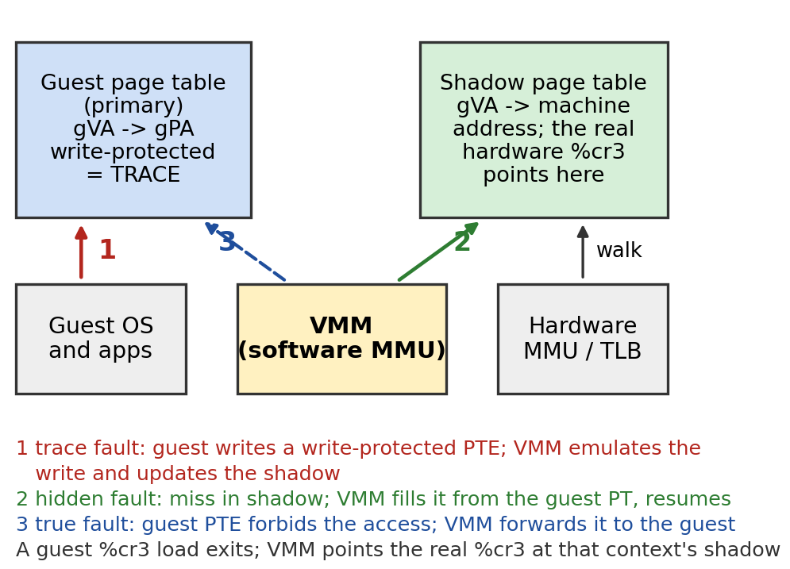
    - fork() marks parent PTEs read-only for copy-on-write (on the hardware VMM each step below is an exit; the fork syscall itself does not exit):
      - Each PTE write on a traced page is a trace fault
      - The child's first cr3 load builds a new shadow
      - Each first touch is a hidden fault
      - later writes to COW pages are true faults (the VMM checks they are not shadowing artifacts).
- Figure 2 – SPECint 2000 and SPECjbb 2005
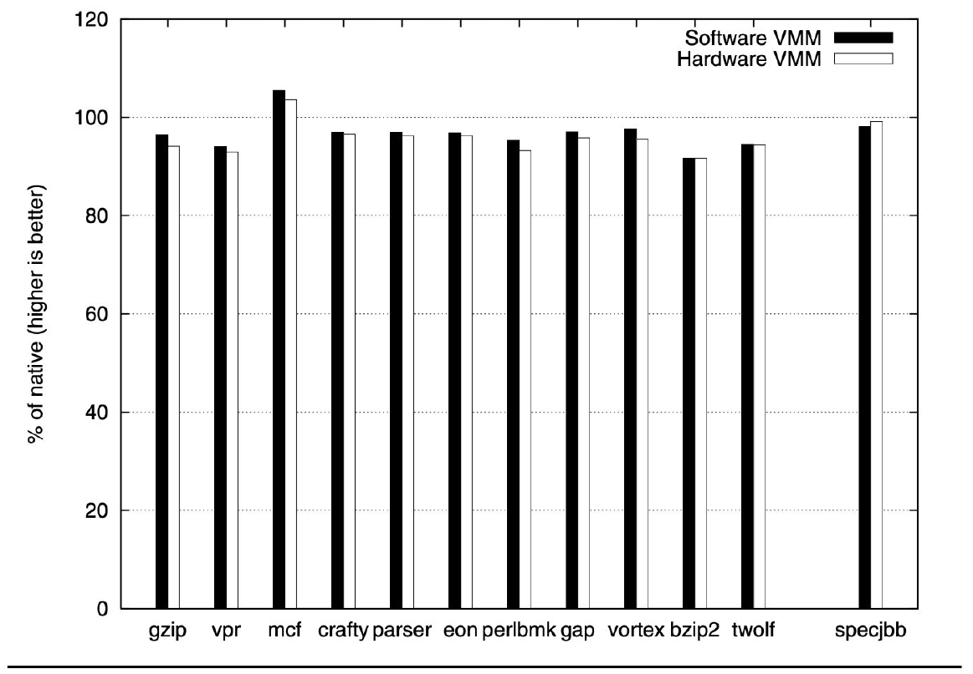
  - These are standard benchmarks of the architecture community, a good fit for ASPLOS; the paper compares the hardware and software approaches on all of them.
  - Both VMMs are close to native because these are user-level compute programs.
    - The software VMM runs user code by direct execution; the hardware VMM always executes directly.
  - Hardware is slightly slower in most:
    - These programs probably do little page table manipulation.
    - Traps are far more expensive than an ordinary page fault, because they exit the hardware mode. (Save all the state into VMCB)
      - "Now" means the hardware-assisted VMM of the paper (VT and SVM, 2006), compared with the software VMM and a native page fault; it is not today. In class the professor added that the traps get even more expensive since they save all the state into the virtual machine block (the VMCB). Paper numbers for the time: a native page fault costs 1093 cycles versus a vmrun/exit round trip (Table 1: entry 2409, exit 1931 on the Pentium 4; 937 and 1186 on Core 2). Later hardware improved exit costs further; that is not in the sources.
  - Software is slightly below native:
    - Hosted architecture: any interrupt forces a switch back to the host OS. There are not many interrupts, but they are expensive enough to interrupt the benchmark slightly.
    - Translation warm-up does not explain it: that applies to OS code, and these programs make few system calls.
  - Faster than native (mcf) is not understood even in the paper:
    - Hidden effects, such as how memory pages map to cache sets and so how many conflict misses occur, are invisible to software; the VM may simply have gotten lucky.
      - mcf is not the native baseline: it is one of the SPEC CPU2000 integer benchmarks plotted in Figure 2 (bars are a percentage of native speed). Paper: "Surprisingly, mcf runs faster than native on both VMMs. Measurement with an external timer to rule out virtual timing jitter showed the performance improvement to be real. We speculate that the VMM positively perturbs TLBs and caches for this combination of workload and hardware but have been unable to prove this conclusively because hardware performance counters cannot be applied to workloads running in VMware Player 1.0.1."
      - The name is not defined in the paper or lecture. General knowledge: SPEC's 181.mcf, a minimum-cost flow solver (network simplex for vehicle scheduling) known for memory-bound pointer chasing, which fits the TLB and cache speculation. The lecture's remark that software was faster than native was about the in nanobenchmark (port 0x80), not mcf.
  - Bars are percent of native. Every program is within 0-9% of native on both VMMs (average slowdown 4% software, 5% hardware); mcf is slightly faster than native on both (authors speculate TLB/cache effects, unproven). SPECjbb: 98% software, 99% hardware.
    - SPECjbb, JIT, and user vs kernel code
      - The JVM is one user process: direct execution at native speed. Its JIT writes new code into user pages, but user code is never translated and its pages are not traced. BT engages only for guest kernel entries (syscalls, timer, faults), where the cached kernel translation is reused. A JIT inside the guest kernel would instead need translation, code-page traces and invalidation on every code write.
        - Paper: "Since the JVM runs as a single user-level process, direct execution dominates SPECjbb's runtime within a VM, just as with SPECint"; SPECjbb is closer to native than SPECint perhaps because of Windows 2003's lower timer interrupt rate (60 Hz versus 100 Hz for the Linux VM). Paper section 3.2: the VMM switches between BT mode and direct execution as the guest changes between kernel and user mode, so BT overhead is limited to kernel code. The points about the JIT's writes and code-page traces are the guide's reasoning, not stated in the paper.
- Figure 3 – Macrobenchmarks
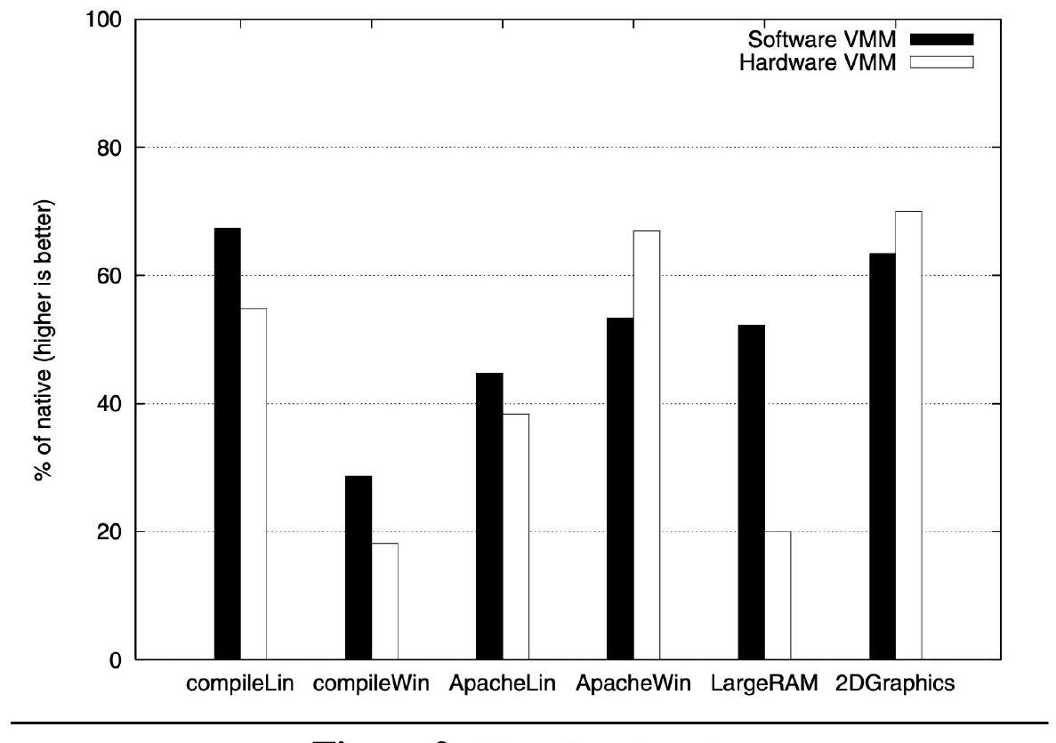
  - Instead of CPU-bound user programs, these test the entire software stack: compiling the Linux kernel, compiling on Windows, Apache on both OSes, a large-memory test, graphics.
  - The differences are much bigger because the OS code now runs heavily under VMware, so the software VMM pays both for translation and for running in the translation cache.
  - Windows goes either way depending on the workload (Apache or compile): the same Apache program runs very differently on the two operating systems, so the results differ.
  - Percent of native.
    - Software wins: Linux and Windows compile, Apache on Linux, Large RAM (paging).
    - Hardware wins: Apache on Windows and 2D graphics (system-call heavy; the SVGA FIFO batches I/O). Reason
    - Software wins where there are many address spaces, PTE writes and page faults;
    - hardware wins where system calls dominate and the address space is single.
      - Software wins (MMU-heavy workloads):
        - Linux kernel compile (make -j8 bzImage): host 265 s, software 393 s (67.4% of native), hardware 484 s (54.8%), an overhead of 128 s versus 219 s. The Windows compile is similar.
        - forkwait: host 6.0 s, software 36.9 s, hardware 106.4 s. Apache on Linux (many address spaces): software 45% versus hardware 38%. PassMark LargeRAM (paging): software 175 op/s versus hardware 67 (native 335).
        - Cause: these workloads exit in the hardware VMM on PTE writes (ptemod 391 versus 12733 cycles), %cr3 loads, true page faults (3927 versus 11242 cycles) and hidden faults. The paper found the guest "spends more time servicing page faults and context switches on the hardware VMM", while the software VMM's adaptive BT turns the traps into callouts or inline code.
      - Hardware wins (syscall-heavy, single address space):
        - Syscall nanobenchmark: the software VMM takes about 2000 cycles more than native (extra code layer and privilege transition), while the hardware VMM runs at native speed ("system calls execute without VMM intervention"). Apache on Windows (single address space by default): hardware 67% versus software 53%. 2D PassMark: hardware 413 op/s (70%) versus software 374 (63%); software instrumentation showed system call overheads.
        - Paper: these workloads have a single address space and few I/O exits relative to the number of system calls, "the exception that proves the rule", since workloads that enter CPL 0 often but rarely perform privileged operations are unusual (the old getpid cached-value cheat).
      - Where each can run the guest without VMM intervention:
        - The software VMM still intervenes on MMU work: page-table writes become callouts or in-cache emulation (391 cycles versus a native single-cycle store). It wins because that intervention is far cheaper than a hardware exit (12733 cycles), not because there is none. It pays extra at kernel entries, indirect branches and privileged instructions.
        - The hardware VMM needs no intervention for system calls, ALU and branch code, and calls and returns (11 cycles, same as native, versus 51 in software), but it exits on MMU events and I/O.
      - Ring 0 is CPL 0, the CPU's most privileged level (kernel mode). In the hardware VMM the guest kernel runs at its own ring 0 inside guest mode (host mode is the VMM's), so a system call enters guest ring 0 with no VMM involvement, and the guest can run most privileged instructions directly. Only the events the VMM selected in the VMCB exit. Paper: "Workloads that enter CPL 0 frequently, but rarely perform privileged operations are unusual." Here "privileged operations" means the operations that cost an exit (I/O, page-table work), not merely any privileged instruction. In the software VMM entering the kernel is itself costly (about 2000 extra cycles per system call).
  - Apache over a network is held below native by the hosted I/O model (all packets go through the host OS), which masks CPU-virtualization differences. PassMark's I/O tests also hide them.
    - Paper section 6.1: "VMware Player uses a hosted I/O model in which all network packets pass through the host OS's I/O stack. Due to this overhead, all four guest/VMM combinations compare poorly to native" (Apache: Windows hardware 67% versus software 53%, Linux software 45% versus hardware 38%). For PassMark: "the two VMMs encountered similar overhead in most PassMark components. Many of these benchmarks stress I/O devices whose latencies easily hide differences in CPU virtualization."
    - Lecture: the professor mentioned the hosted architecture (on an interrupt "we had to basically switch back to the host operating system", so the benchmarks run slightly below native) and that Apache gave different results on different operating systems. The masking explanation itself is the paper's.
- Figure 4 – Virtualization Nanobenchmarks
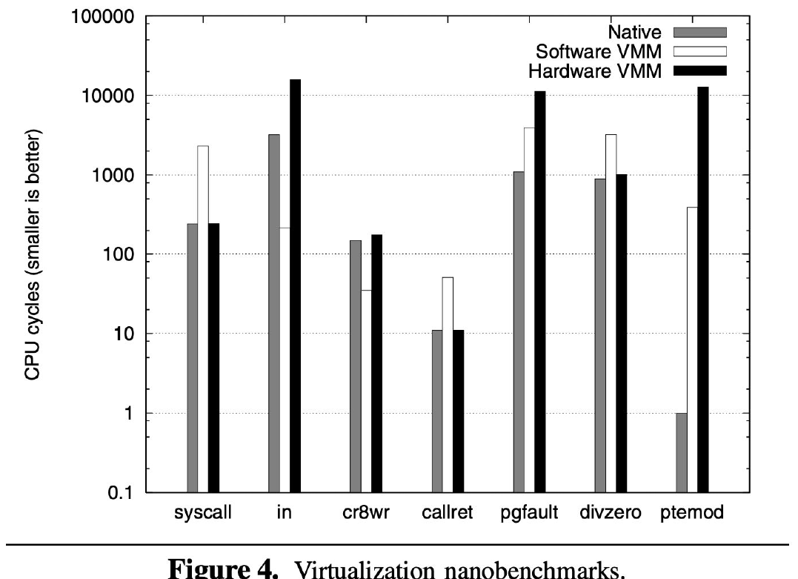
  - Nanobenchmarks measure single micro-operations in a tight loop:
    - system calls (the app traps into the guest OS, which returns immediately)
      - system calls run at speed on the hardware VMM; the software VMM has some overhead because execution goes from direct execution up into the binary translator.
    - In
      - Why the software VMM is faster than native: The in reads a well-known port that the BIOS uses (port 80 on the PC). An in from a port just reads the last value written (out) to it, so emulating it is a pretty fast device-emulation step.
      - Natively it has to talk to a chipset on the motherboard. In the software VMM it is a very fast callout from the translator, which beats native. Measured: in = 216 cycles vs 3209 native (15x faster than native: it talks to an in-memory virtual chipset, not hardware).
      - In the hardware VMM it must trap into the VMM first and then do the fast emulation, so the trap dominates.
    - a call and return in ring 0
      - The hardware VMM runs call and return exactly at native speed. In ring 0 the software VMM must do the lookup in the translation cache.
    - modifying a page table entry
      - Natively this is a single store into a word of memory, so super fast. In both VMs something has to happen on the change. The hardware VMM can only trap, and its traps are really expensive; the software VMM has faster traps and can even get rid of them with adaptive translation. So the difference is always trapping versus faster traps that can be removed.
    - cr8wr is a weird privileged register
      - A write to a memory location
      - Take a privileged instruction and change it to a memory store instruction. Measured: cr8wr = 35 cycles (4x faster than native).
      - HW becomes a trap, which is why it’s slow
  - Mechanism: Why each VMM wins: reading the benchmarks
    - TL;DR
      - Problem – decide which VMM is better, and why.
      - Mechanism of explanation – cost of each operation on each VMM (nanobenchmarks) times how often the workload does it (Figure 5).
      - Trade-off – hardware wins where the guest enters ring 0 often but rarely does anything privileged; software wins on PTE writes, context switches, page faults and I/O.
        - Two separate effects explain the results. First, hardware exits cost more per event: the paper says hardware virtualization replaces faults with "costlier guest/vmm round-trips". Table 1: VM entry 2409 and page-fault exit 1931 cycles on the Pentium 4 (937 and 1186 on Core 2), about 4340 per round trip on the P4 versus about 2030 for a classical trap-and-emulate (my arithmetic).
        - Second, software BT removes the trap instead of paying less for it: adaptation turns it into a callout (1254 cycles) or in-cache code (216), and the translation cost (about 2300 cycles per x86 instruction) is amortized. "The hardware VMM is unable to adapt to frequently exiting workloads."
        - Paper summary: "hardware virtualization delivers native speed for anything that avoids an exit but levies a higher cost for the remaining exits (on current hardware)". First-generation hardware has no MMU virtualization, so many page-table operations become costly exits that cannot be adapted away. Mixed results: ptemod software 391 versus hardware 12733 cycles; pgfault 3927 versus 11242; call/ret software 51 versus 11 (hardware wins); hardware also wins system calls.
        - Why the hardware exit itself is more expensive (paper section 5 and nanobenchmarks): for a true page fault the software VMM (3927 cycles) beats the hardware VMM (11242) "due mostly to the shorter path whereby the software VMM receives control; page faults, while by no means cheap natively (1093 cycles on this hardware), are faster than a vmrun/exit round-trip."
        - The software VMM gets an ordinary exception. The hardware VMM pays a vmrun/exit round trip, then reads exit fields from the VMCB (178 cycles per read, 171 per write on the P4) and "must fetch and decode the trapping guest instruction to emulate it", whereas a BT callout receives a predecoded instruction. In the divzero nanobenchmark the fault goes to the guest with no exit: hardware 1014, native 889, software 3223 cycles, so the cost is the exit, not the fault. Why the transition is slow microarchitecturally is not explained in the paper (reasoning: large guest and host state is saved and restored).
      - Breaks when – exits get cheaper or nested paging arrives (costs change); the broad profile stays.
    - Key points
      - Fig 2: SPECint 2000 slowdown 0-9% (average 4% software, 5% hardware); SPECjbb 98% / 99% of native.
      - Fig 4 table below
        - Fig 5 (XP boot/halt): the hardware VMM loses in in/out and ptemod.
      - forkwait (40,000 fork+wait): native 6.0 s, software 36.9 s, hardware 106.4 s: overhead 4.4x larger on hardware. Linux kernel compile: native 265 s, software 393 s (67%), hardware 484 s (55%).
      - Caveat: the measured Intel chip lacks 64-bit segment limits (same speed on Opteron).
    - Dependence on assumptions
      - Assumptions this mechanism relies on:
        - Exits cost thousands of cycles
        - The MMU is virtualized in software
        - BT can adapt (patch hot instructions)
        - A VMM is either software BT or hardware, not both
        - CPU and MMU virtualization cost dominates the guest's runtime
      - Consequences of changed workloads and assumptions
        - Tiny processes (fork storms): the hardware VMM suffers because PTE writes and cr3 loads dominate, so the software VMM wins big.
        - One multi-threaded server with buffered I/O and many syscalls: few exits, so the hardware VMM is competitive (these are the two workloads where it won).
        - A network-bound guest with hosted I/O: the I/O path dominates both VMMs, so CPU virtualization differences are muted and both are far below native.
        - Even if exits were free, the hardware VMM would still trail on MMU operations because of state reconstruction and instruction decode (the Core 2 forkwait numbers in Mechanism: The hardware VMM show this).
        - The hardware VMM cannot adapt: a frequently trapping instruction keeps exiting.
        - A hybrid VMM that picks BT or hardware by heuristics is possible in principle, but the heuristics were immature in 2006: it could take hardware syscalls with a software MMU, and Intel would also need a non-segment protection.
    - Connections
      - Each row is a consequence of the BT, trace, hardware VMM and nested-paging mechanisms.
    - fork on each VMM
      - Software: traced PTE writes become inline 391-cycle routines, a new shadow is started at cr3 load, eager fill saves hidden faults; syscalls cost +2000.
      - Hardware: syscalls native, but every PTE write, cr3 load and fault is an exit (12733 cycles per PTE write). Nested paging removes those exits.
    - Timing
      - A real PC BIOS (Phoenix) pokes the disk controller and then spins in a loop reading (in) until the controller replies. If the in is too fast, the loop goes around so many times that the BIOS declares the disk controller dead; the first VMware version booted with a "disk controller is dead" error.
      - Fix: make the in a little slower. This was easy with the binary translator, which can generate arbitrary code, so the emulation of a device can have arbitrary delays. On the hardware VMM the loop just spins taking traps, which does not slow boot much since it waits for the disk controller anyway.
      - AMD later released a processor tuned so that some instructions, including this one, took far fewer cycles, and hit the same problem with old operating systems. VMware could fix it in software; slowing down a CPU was a much bigger problem for AMD.
- Figure 5 – Sources of Virtualization Overhead in an XP Boot/Halt
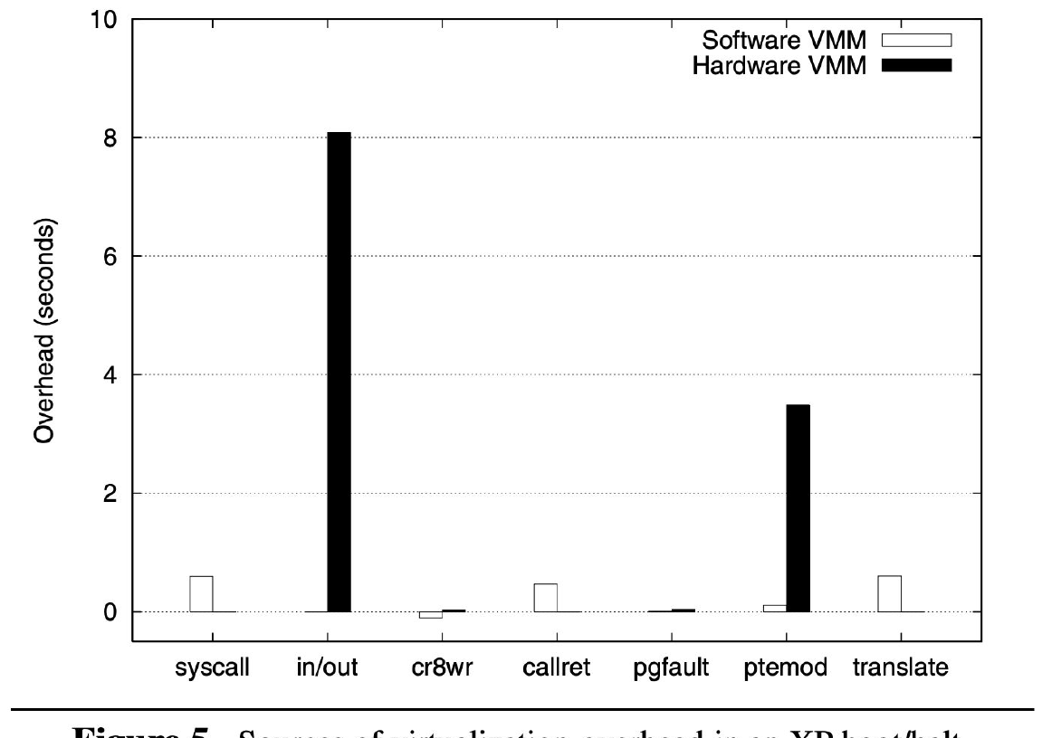
  - Windows XP was booted and halted, and the time spent was broken down by operation.
  - The really big difference is in in/out: during boot, BIOS code talks to the chipset. In the software VMM that is very fast because software is talking to software; in the hardware VMM each instruction takes a trap that dominates the cost, followed by a very fast emulation.
  - Seconds of overhead by operation. Hardware: in/out (about 8 s, mostly atypical BIOS code that runs only at boot) and ptemod (about 3.5 s; over a million PTE modifications). Software: small bars (syscall and translate). Pgfault matters little because boot has few true page faults.
  - Message: nanobenchmark cost * operation frequency decides the winner; translation time is rarely significant because the translation cache captures the working set.
- x86 Memory Virtualization
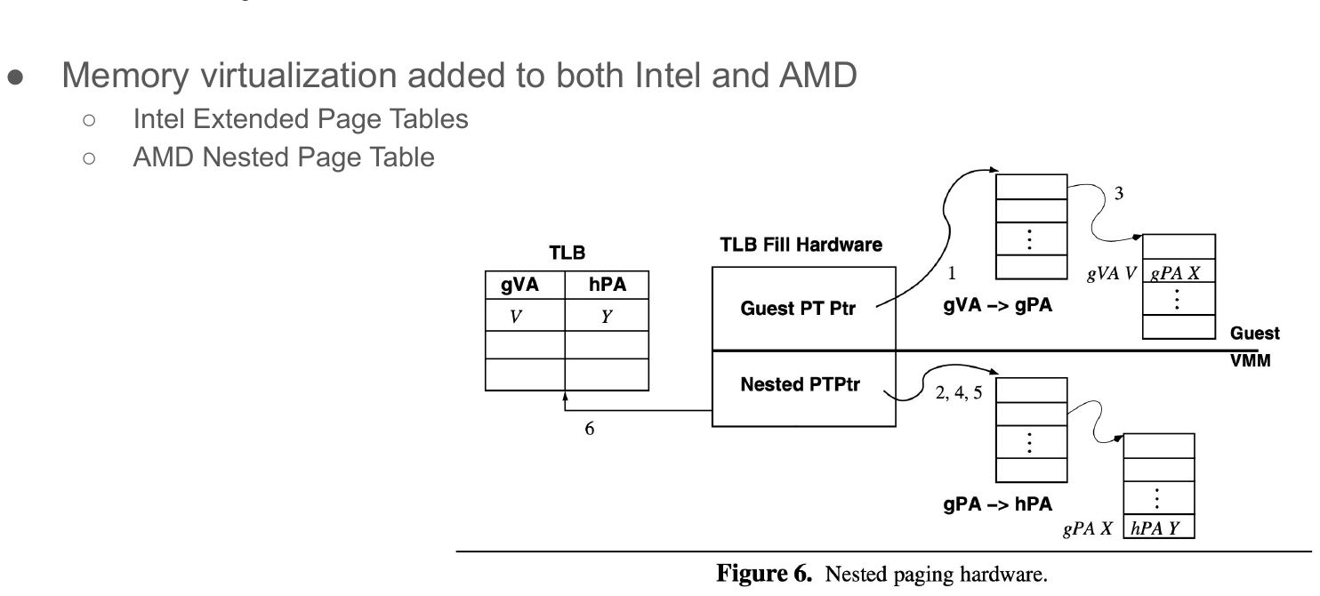
  - Intel and AMD took away that memory has to be virtualized in some way. The guest OS keeps its own page tables, and the address they produce is run through another page table that the VMM controls.
  - Because of this, traces on page tables are not needed anymore. Essentially all VMs running in the cloud today use it, since they do not need to take the traps.
    - The guest OS's own virtual memory maps VPN to PPN (guest virtual to guest "physical"), but guest "physical" memory is not real machine memory, so the VMM must also virtualize physical memory (PPN to MPN) and the CPU must end up with VPN to MPN. Shadow page tables did that in software: the VMM composes the two maps and traces keep the result coherent. The nested table does it in hardware: the hardware walks both levels and the TLB caches VPN to MPN.
    - Before MMU virtualization the VMM managed VPN to MPN in software in both VMMs. Paper section 4.2: "Since current virtualization hardware does not include explicit support for MMU virtualization, the hardware VMM also inherits the software VMM's implementation of the shadowing technique". The lecture says cloud VMs today use the extra page tables; it does not say whether anyone still uses BT.
    - General knowledge, not in the sources and not verified for 2026: mainstream x86 hypervisors rely on hardware-assisted virtualization with nested paging, BT for virtualization is largely historical, and translation techniques survive elsewhere (emulators, JITs, cross-ISA translators).
  - Memory virtualization added to both Intel and AMD
    - The fix for the missing MMU virtualization: the slide's Figure 6 shows the TLB holding guest-virtual to host-physical entries filled by a two-level hardware walk.
    - Intel Extended Page Tables
    - AMD Nested Page Table
    - Both are similar to IBM's s/370 interpretive execution design, which solved the trace/hidden-fault/context-switch trade-off in hardware. The hardware walks the guest table (gVA to gPA) and the nested table (gPA to host physical), so the VMM no longer needs traces or exits for guest PTE writes and context switches.
    - Cost: a TLB miss touches both tables, about M x N memory references worst case for an M-level guest table on an N-level nested table (24 for 4 x 4, against 4 natively), so misses cost more. The paper's bet: the techniques that make ordinary TLBs work (large associative multi-level TLBs, caching) apply to the nested walk, so nested paging should easily repay "slightly slower" TLB misses.
  - Mechanism: Nested (extended) page tables
    - TL;DR
      - Problem – shadow page tables force exits for PTE writes, cr3 loads and hidden faults.
      - Mechanism – hardware walks TWO tables: the guest's (gVA → gPA, guest controls %cr3 and PTEs) and a nested table kept by the VMM (gPA →hPA); the TLB caches gVA → hPA.
      - Trade-off – no traces, no hidden faults, no exits for guest context switches; but a TLB miss is a two-dimensional walk and costs more.
      - Breaks when – TLB-miss-heavy workloads with large working sets (walk cost), unless caches or large pages help.
    - Key points
      - Walk (Figure 6): 1 %cr3 (a guest physical address) 2 is translated through the nested table 3 read the guest PDE 4 its gPA translated again 5 read the guest PTE, then a third nested walk for the data page 6 fill TLB with (V, Y). No software involved.
    - How it works
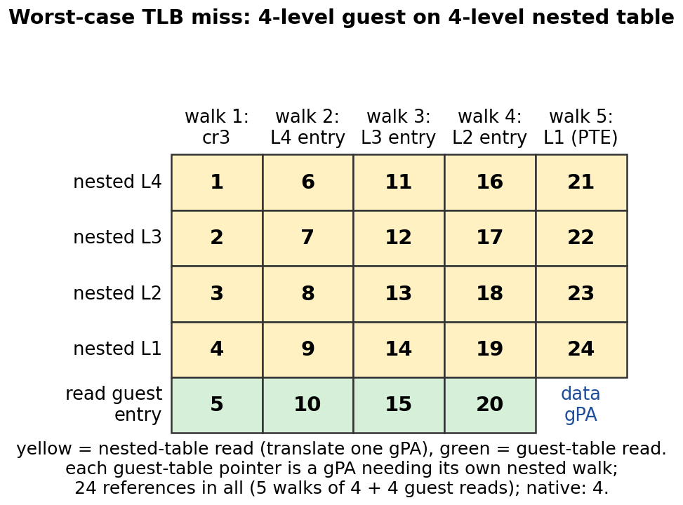
    - Dependence on assumptions
      - Assumptions this mechanism relies on:
        - TLB hit rate is high
        - Walk caches help
        - The VMM can map guest memory as it likes
        - Nested mappings are 4KB
      - Consequences of relaxing an assumption
        - PTE-write or fork-heavy workloads gain a lot: there are no trace faults and no exits, so ptemod becomes a native store.
        - A huge random-access working set where TLB misses dominate can lose: each miss needs up to about 6x more references (about M x N worst case, 24 versus 4 natively for 4 x 4), which is where the paper's bet that walk caches and large associative TLBs absorb the cost fails. A nested table with large pages helps (Superpages lecture: TLB reach matters more under virtualization).
        - Relying on nested paging makes software tricks like adaptation and eager shadow fill unnecessary, but the VMM loses the flexibility to choose the trace/fault trade-off.
        - Large nested pages would cost ESX-style sharing opportunities.
    - Connections
      - Replaces shadow tables
        - fixes the hardware VMM's worst exits
        - The paper only anticipates it (section 7.4).
- Related ideas
    - Paravirtualization (modified guests) and IBM s/370 SIE (hardware interpretive execution that VT/SVM resemble): section 2.5 of the paper.
      - Paravirtualization is not bare metal: a VMM or hypervisor is still there. The guest OS is modified so it cooperates with the VMM through a new guest-to-VMM interface (higher-level information, calls into the VMM) instead of relying on trapping or translating its privileged operations.
      - Paper section 1: paravirtualization, or changing the guest operating system to permit virtualization, has produced promising results, but such changes are not always practical or desirable. Section 2.5: implementors "modified guest operating systems to provide higher-level information to the VMM", which "relaxes Popek and Goldberg's fidelity requirement to provide gains in performance, and optionally to provide features beyond the bare baseline definition of virtualization, such as controlled VM-to-VM communication".
      - Section 8: it "gains performance and permits a simpler VMM design. However, it sacrifices the ability to run legacy and proprietary operating systems. Moreover, a new interface between the guest and VMM must now be standardized, documented and supported in addition to the existing interface between OS and hardware."
      - VMware's work has the opposite goal: run unmodified guests such as Windows. In ESX, a paravirtual guest that sees machine pages needs no hiding and no shadow table, but gives up transparency.
    - Transmeta Crusoe (hardware plus software x86 BT), picoJava (a JVM frozen in hardware) and the RISC/CISC lesson: measurement beats intuition that hardware always wins.
    - Hybrid VMM and the less-trace-intensive MMU algorithms were work in progress in 2006 (sections 7.2-7.3).
    - Intel VT uses vmlaunch/vmresume; vmrun is AMD's name (the paper uses vmrun for both).

